
DATA MINING
Lab Manual
Name: Mohammad Saud
Roll No: 2023-BS-AI-153
Submitted to: Mr. Arham

Department Of Computational Sciences
THE UNIVERSITY OF FAISALABAD
Lab 1: Introduction to KNIME
Real-World Scenario
A retail company has gathered a large amount of sales data from various product categories and needs an organized method to evaluate its business performance. The management team wants to determine the total revenue generated, the average value of customer orders, the categories contributing the highest income, and the products generating the most sales. This lab demonstrates how these business requirements can be addressed using KNIME through a visual, node-based workflow operating on a CSV dataset.
Dataset
The dataset used in this experiment is a Retail Sales CSV file, where each row represents an individual sales transaction and contains information such as product details, quantities sold, prices, order dates, and categories.
Practical Objectives
Upon completing this lab, students will gain practical experience with the fundamental features of the KNIME Analytics Platform. Specifically, students will be able to:
- Import a CSV file into a KNIME workflow using the CSV Reader node.
- Examine and modify data types whenever necessary.
- Produce descriptive statistical summaries to understand the characteristics of the dataset.
- Create a new Revenue attribute using the Math Formula node.
- Calculate important business performance indicators using GroupBy and Sorter nodes.

Procedure
Step 1: Create a New Workflow
Open the KNIME Analytics Platform and navigate to File → New → New KNIME Workflow. Assign the workflow the name Retail Sales Analysis and click Finish. A new blank workspace will be created where all nodes and their connections can be designed.

Step 2: Import the Dataset
Locate the CSV Reader node from the Node Repository panel and drag it onto the workflow canvas. Double-click the node to access its configuration settings. Select Browse, choose the Retail Sales CSV file, and press OK.
Right-click the node and select Execute. Once the execution is complete, right-click again and choose View Table to verify that the dataset has been loaded successfully.
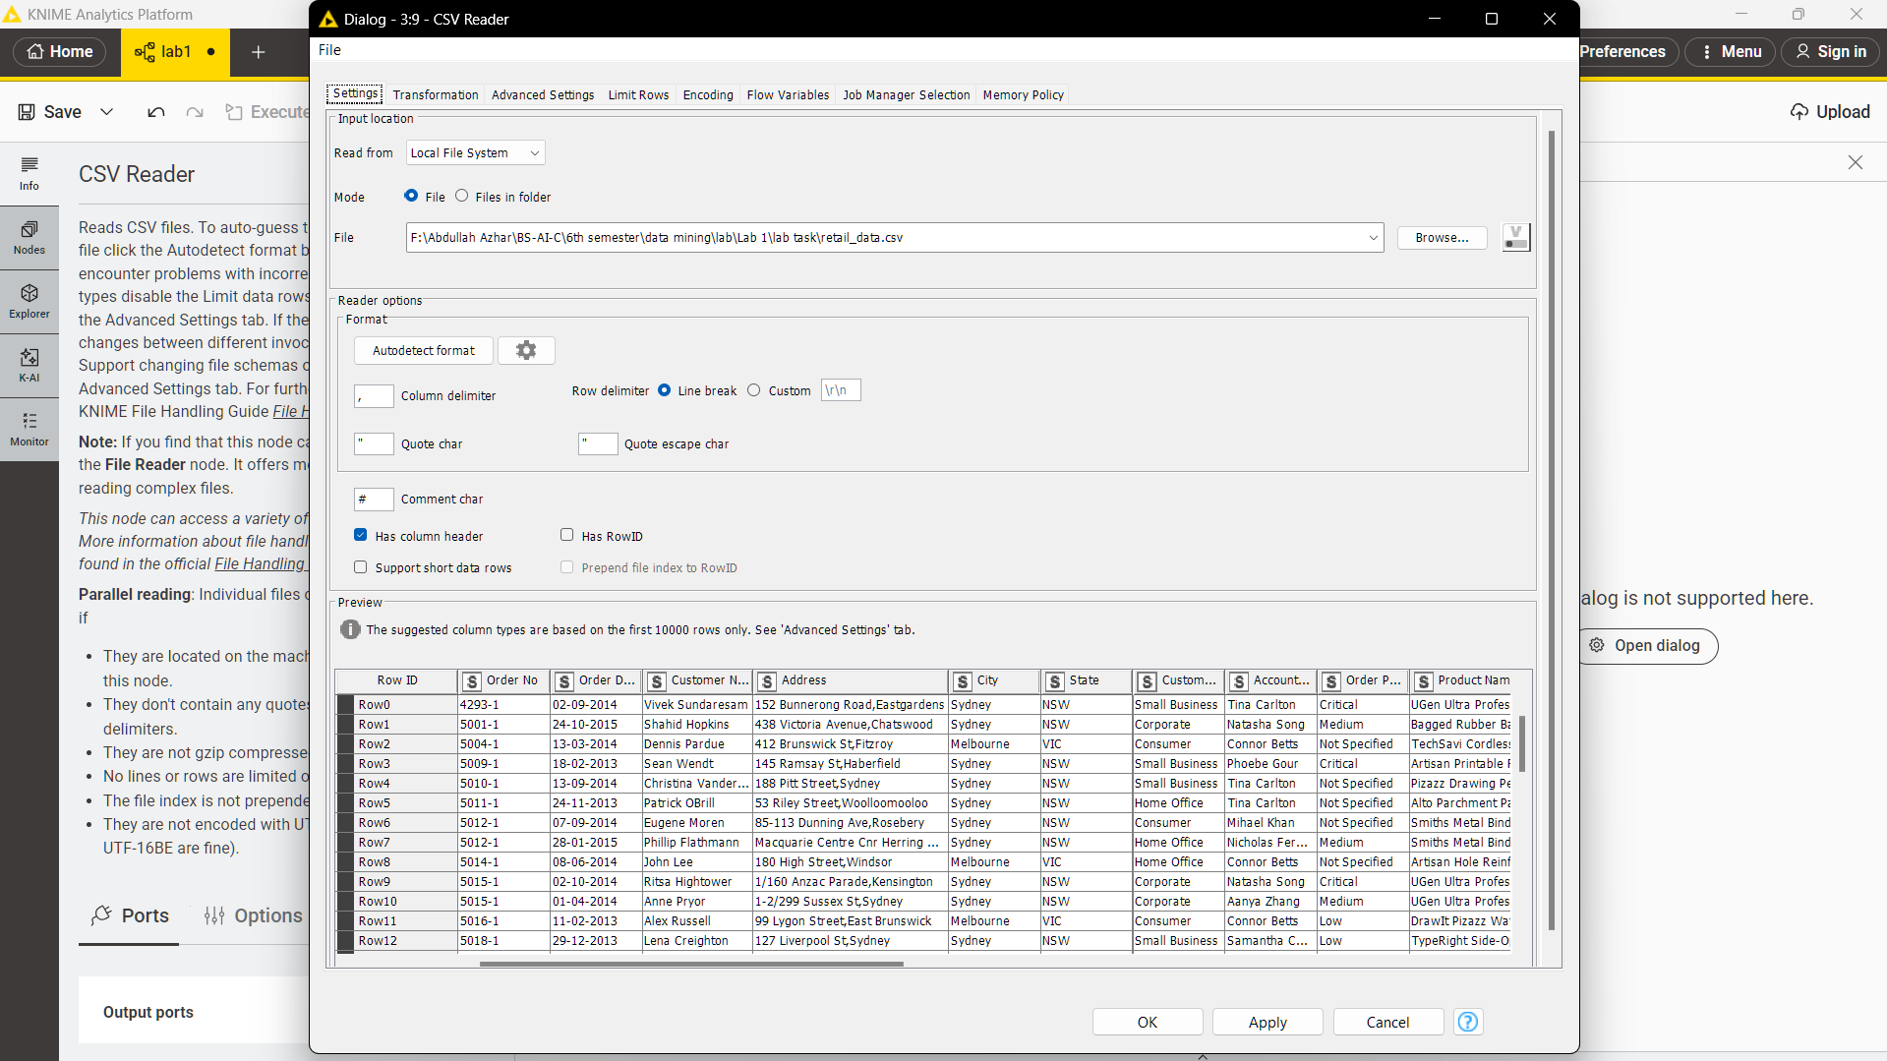

Step 3: Validate Data Types
After importing the data, inspect the data types assigned to each column. Ensure that:
- Quantity is stored as an Integer.
- Price is stored as a Double.
- Order Date is stored as a Date format.
- Category is stored as a String.
If any column has been assigned an incorrect data type—for example, if the Price column is imported as text—use the appropriate conversion nodes before proceeding. Use the String to Number node for numerical fields and the String to Date&Time node for date attributes.
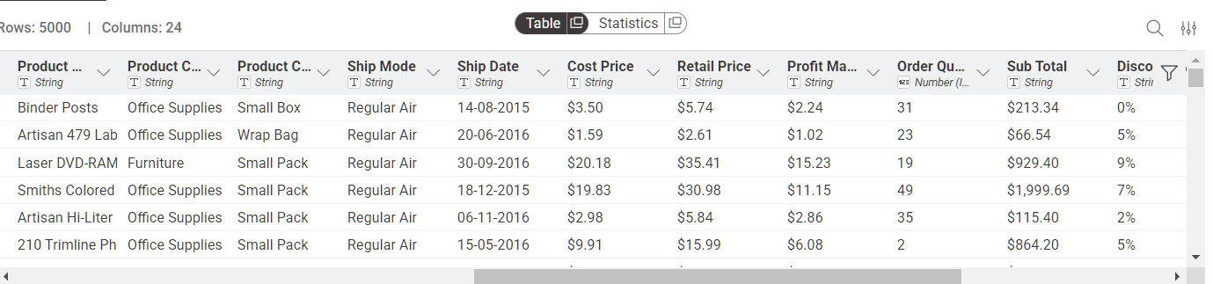

Step 4: Generate Descriptive Statistics
Add a Statistics node and connect it to the output of the CSV Reader node. Execute the node and examine the generated results.
The Statistics node provides information such as:
- Mean
- Minimum value
- Maximum value
- Standard deviation
- Sum of numeric columns
This initial analysis provides an overview of the dataset and helps identify inconsistencies or unusual values before further processing.
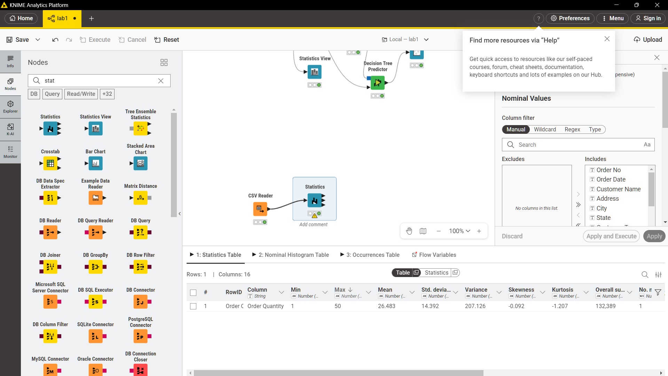

Step 5: Create the Revenue Column
Insert a Math Formula node and connect it to the CSV Reader. Within the node configuration, create a new attribute named Revenue using the following formula:
$Quantity$ * $Price$
Execute the node. A new Revenue column will be generated, containing the revenue earned from each individual transaction. This column will serve as the foundation for all subsequent KPI calculations.
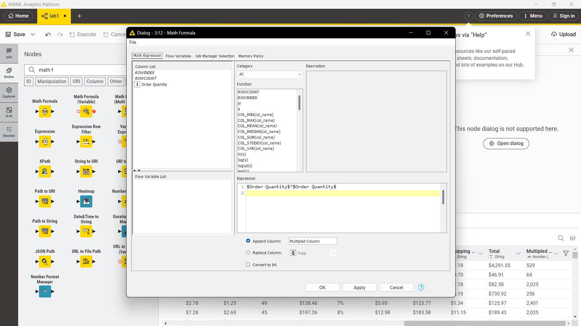

KPI 1: Total Revenue
Add a GroupBy node without selecting any grouping column. Under the Manual Aggregation section, choose the Revenue column and set the aggregation method to Sum.
After execution, the output will contain a single row representing the total revenue generated from all sales transactions.
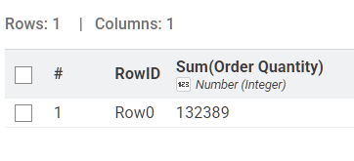

KPI 2: Average Order Value
Insert a GroupBy node and group the data by Order ID while aggregating the Revenue column using the Sum operation. This will calculate the total revenue for each order.
Connect a second GroupBy node without any grouping field and calculate the Mean of the aggregated values. The resulting output represents the average value of customer orders.
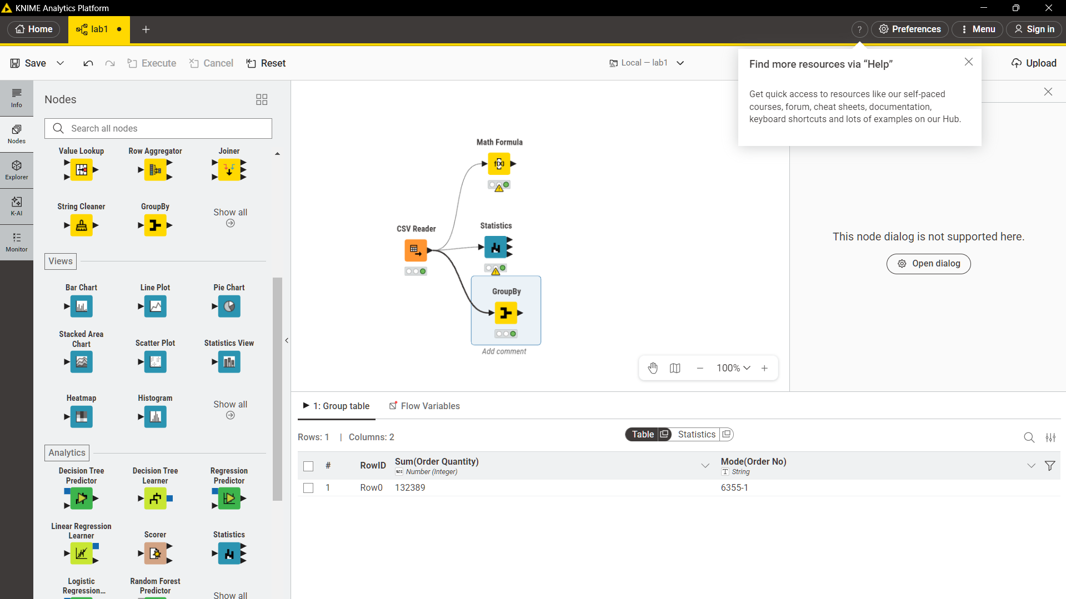

KPI 3: Revenue by Category
Add another GroupBy node and group the data according to the Category column while summing the Revenue values.
Connect a Sorter node and configure it to sort the results in descending order of revenue. The resulting table ranks all product categories according to their contribution to total sales.
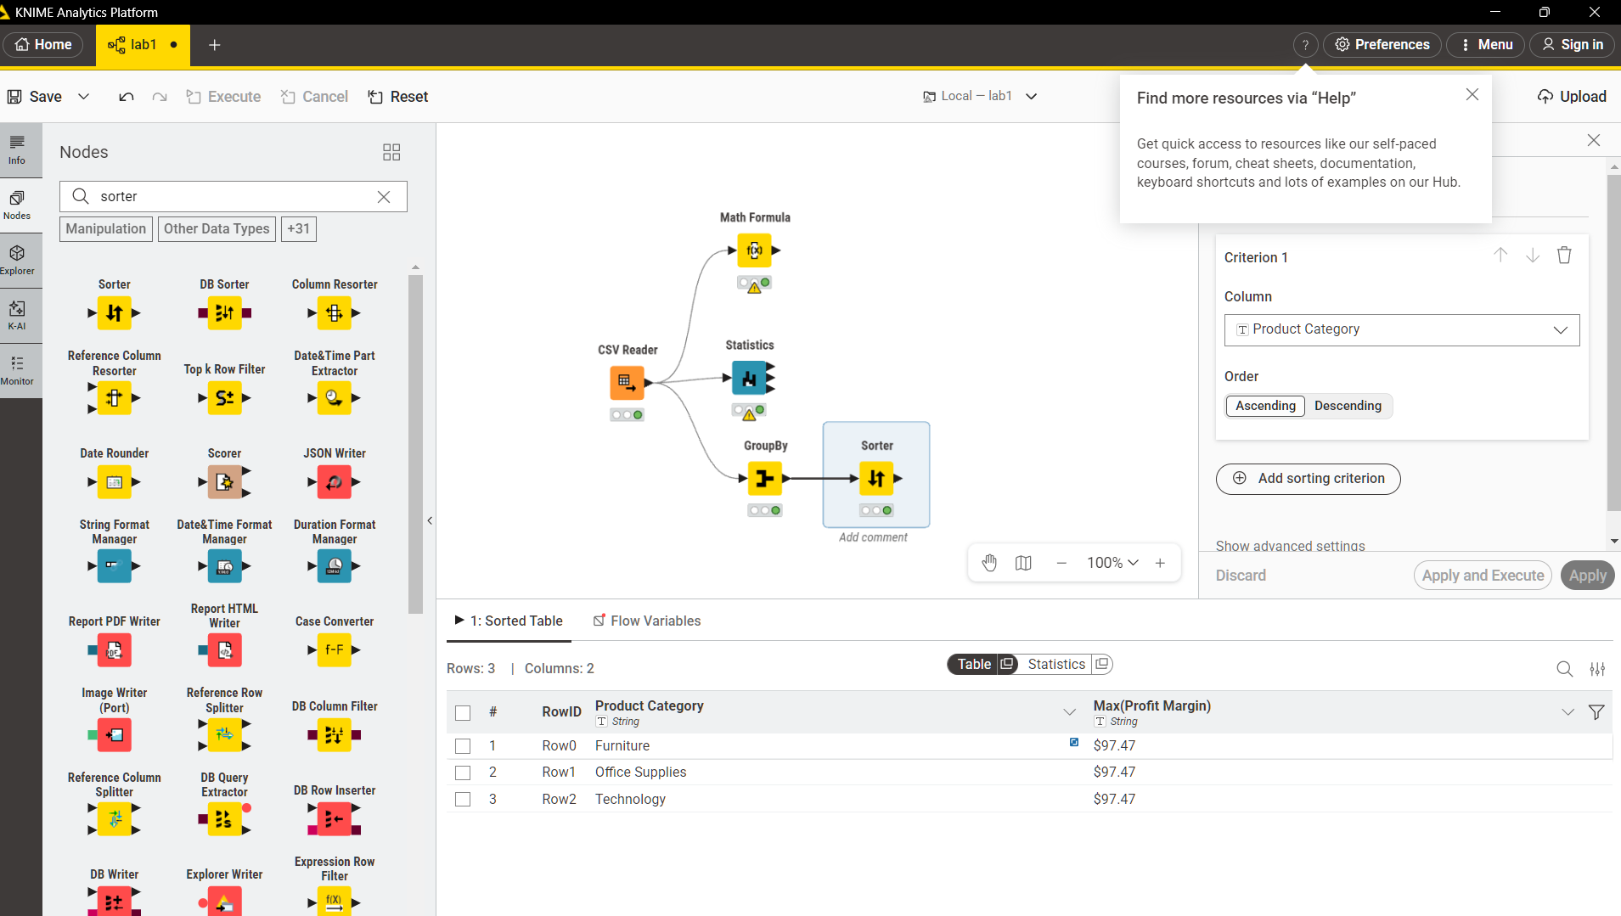

KPI 4: Top Performing Products
Use a GroupBy node to group the dataset by Product Name and aggregate the Revenue values using the Sum function.
Attach a Sorter node and arrange the results in descending order based on revenue. The highest-ranked entries identify the products generating the greatest amount of income.
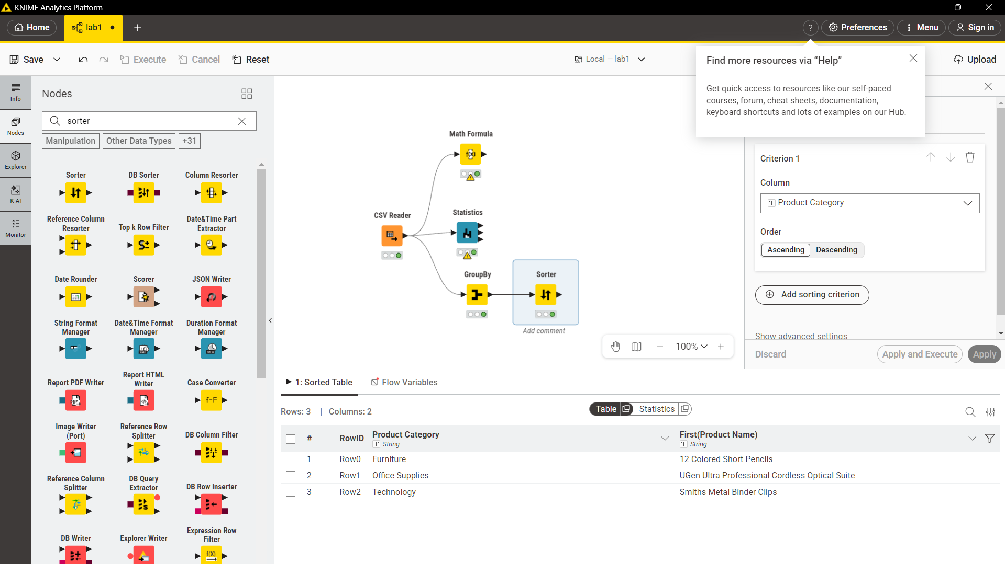

KPI Summary
KPI | Calculation Method | KNIME Nodes Used
Total Revenue | Sum of (Quantity × Price) | Math Formula → GroupBy (Sum)
Average Order Value | Mean revenue per Order ID | GroupBy (Order ID) → GroupBy (Mean)
Category Revenue | Revenue aggregated by Category | GroupBy (Category) → Sorter (Descending)
Top Products | Revenue aggregated by Product Name | GroupBy (Product Name) → Sorter (Descending)

Lab 2: CRISP-DM Methodology
Real-World Scenario
An online retail company has noticed a steady decline in its revenue and believes that many of its customers are discontinuing their purchases. To address this issue, management wants to identify customers who are likely to leave so that retention strategies and targeted marketing campaigns can be implemented before these customers churn. This lab employs the CRISP-DM (Cross-Industry Standard Process for Data Mining) framework to organize and manage the complete data mining process, beginning with business understanding and ending with model evaluation.

Dataset
The experiment utilizes a Customer Churn Dataset that includes customer demographic information, subscription records, service usage patterns, customer support interactions, and a binary churn indicator specifying whether a customer has left the service.

Practical Objectives
After completing this lab, students will be capable of applying all six phases of the CRISP-DM methodology to solve a real-world customer churn prediction problem using Orange Data Mining. Specifically, students will:
- Define and document business objectives and project requirements.
- Explore and understand the characteristics of the dataset.
- Prepare and preprocess data for predictive modelling.
- Build machine learning models for churn prediction.
- Evaluate model performance using different metrics.
- Develop a deployment strategy based on the selected model.

Procedure
Step 1: Business Understanding
The primary business objective is to predict customer churn accurately so that preventive actions can be taken to retain valuable customers.
The success criteria for this project are:
- Model Accuracy of at least 80%.
- ROC-AUC score greater than 0.75.
Additionally, define what customer churn means within the organization's context and identify all available data sources that may contribute to the prediction process.

Step 2: Data Understanding
Open Orange Data Mining and import the Customer Churn CSV file using the File widget.
Connect a Data Table widget to inspect the dataset and review its rows and columns. Then, use the Feature Statistics widget to examine:
- Distribution of variables
- Number of missing values
- Balance between churned and non-churned customers
Finally, calculate and record the overall churn rate to establish a baseline for future comparisons.
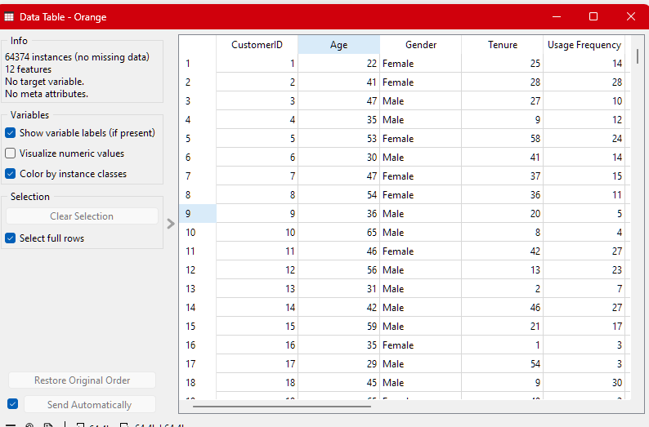

Step 3: Data Preparation
Add the Preprocess widget to clean and prepare the dataset.
Perform the following preprocessing tasks:
- Replace missing numerical values using the mean.
- Replace missing categorical values using the most frequent category.
- Encode categorical attributes with the Continuize widget.
- Normalize all numerical features to place them on a comparable scale.
- Remove irrelevant identifier columns, such as CustomerID, since they do not contribute to prediction performance.
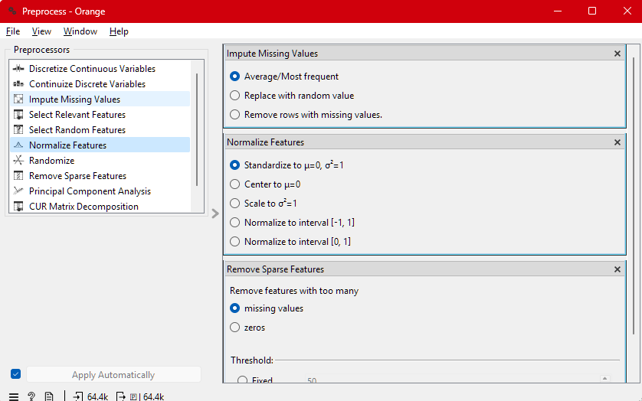

Step 4: Model Development
Add two machine learning algorithms to the workflow:
- Logistic Regression
- Random Forest
Connect both learners to the preprocessed dataset and link them to the Test and Score widget.
Configure the widget to use:
- 10-fold cross-validation
- Churn as the target variable.
Execute the workflow to train and evaluate both models.

Step 5: Model Evaluation
Review the output generated by the Test and Score widget and record the following performance measures:
- Accuracy
- Precision
- Recall
- F1-Score
- ROC-AUC
Next, connect the ROC Analysis widget to visualize the ROC curves for both models.
Compare the performance of the models against the success criteria established in Step 1 and determine which model provides the most effective solution for predicting customer churn.
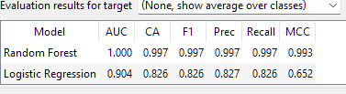

KPI Summary
KPI / Metric | Description | Random Forest | Logistic Regression | Orange Widget
Model Accuracy (CA) | Percentage of correctly classified instances | 99.7% | 82.6% | Test and Score
ROC-AUC Score | Ability of the model to distinguish between classes | 1.000 | 0.904 | Test and Score
F1-Score | Combined measure of Precision and Recall | 0.997 | 0.826 | Test and Score
Precision | Correctness of positive churn predictions | 0.997 | 0.827 | Test and Score
Recall | Ability to identify all churned customers | 0.997 | 0.826 | Test and Score

Conclusion
Based on the evaluation metrics, the Random Forest model significantly outperforms Logistic Regression, achieving higher values across all performance indicators. Therefore, Random Forest is the preferred model for this customer churn prediction task and can be used to support proactive customer retention strategies.

Lab 3: Data Cleaning
Real-World Scenario
A healthcare institution is preparing patient information gathered from various departments for a disease prediction project. However, the collected data contains several issues, including missing medical values, duplicate patient records caused by system migrations, and noisy sensor measurements. Before any predictive analysis can be performed, the dataset must be cleaned and transformed into a reliable and high-quality form suitable for clinical machine learning applications.

Dataset
The experiment utilizes a Healthcare Dataset containing patient information such as:
- Age
- Gender
- Blood Pressure
- Glucose Level
- Body Mass Index (BMI)
- Diagnosis Codes
- Admission Dates
The dataset intentionally includes missing values, duplicate records, and outliers to simulate real-world data quality problems.

Practical Objectives
By the end of this lab, students will be able to:
- Detect and handle missing data using different imputation techniques.
- Identify and eliminate duplicate records from the dataset.
- Apply smoothing methods to reduce noise in the data.
- Detect and manage outliers using Python.
- Calculate and compare data quality scores before and after the cleaning process using both RapidMiner Studio and Python.

Procedure
Step 1: Load and Examine the Dataset
Begin by importing the healthcare dataset using the Read CSV operator in RapidMiner.
Connect the dataset to a Retrieve operator and execute the process. Open the results panel and carefully examine the dataset by noting:
- The total number of records.
- The data type of each attribute.
- Columns containing missing values or invalid entries.
This initial profiling stage provides a clear understanding of the quality and structure of the dataset before any cleaning operations are performed.
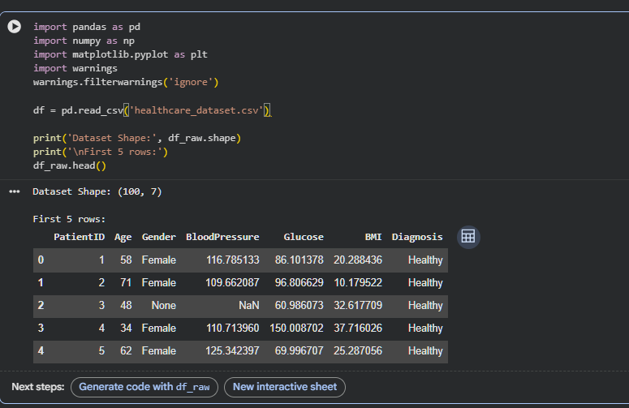
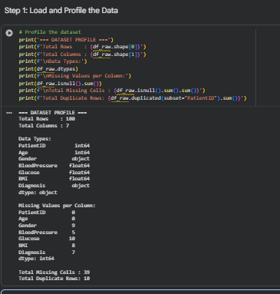

Step 2: Handle Missing Values
Add the Replace Missing Values operator to the workflow.
Configure the operator using the following strategies:
- For numerical attributes such as Glucose and BMI, replace missing values with the Average (Mean) of the column.
- For categorical attributes such as Diagnosis, replace missing values with the Most Frequent Value (Mode).
If a column contains more than 40% missing values, remove it completely using the Remove Useless Attributes operator, as excessive missing information may reduce the reliability of the analysis.

Step 3: Remove Duplicate Records
Insert the Remove Duplicates operator and configure it to identify duplicate records using the PatientID field.
Retain only the first occurrence of each patient record and remove all subsequent duplicates.
After executing the operator, record the total number of duplicates that were removed.
Next, switch to Python and validate the cleaning process using the Pandas function:
df.duplicated().sum()
Run the command both before and after duplicate removal to confirm that the duplicate records have been successfully eliminated.
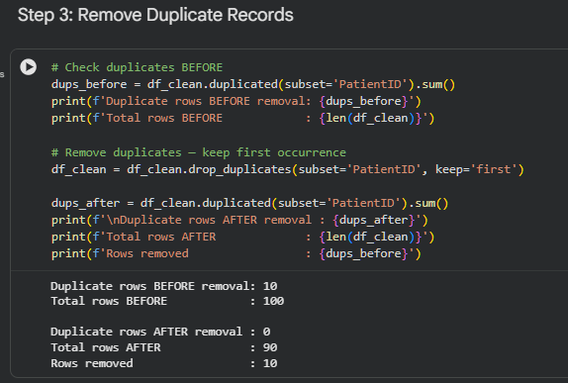

Step 4: Apply Noise Filtering in Python
Export the cleaned dataset from RapidMiner as a CSV file and load it into Python using the Pandas library.
To reduce noise in sensor readings, apply a Rolling Mean Smoothing technique with a window size of 3 to the BloodPressure column.
To identify and visualize outliers:
- Create Box Plots using Matplotlib for the Glucose and BMI columns.
- Compare the distributions before and after applying noise filtering.
Finally, limit extreme values by capping them at the 1st percentile and 99th percentile using the following function:
np.clip()
This process reduces the influence of abnormal observations while preserving the overall distribution of the data.
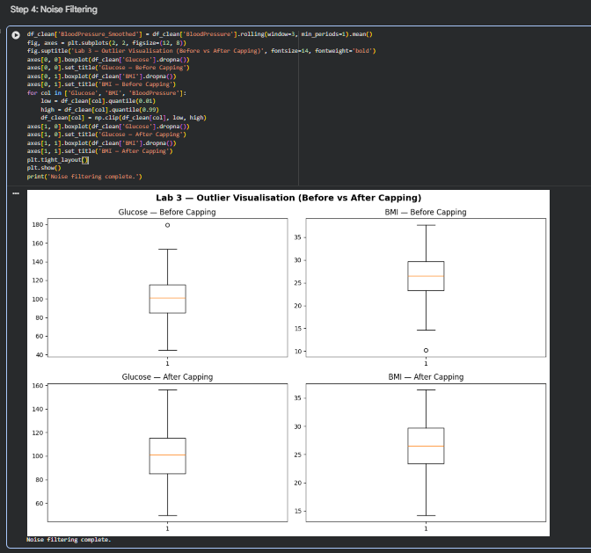

KPI Summary
KPI | Calculation Method | Result
Percentage of Missing Values Reduced | ((Missing Values Before − Missing Values After) ÷ Missing Values Before) × 100 | 100%
Duplicate Removal Percentage | (Duplicates Removed ÷ Total Records Before Cleaning) × 100 | 10%
Data Quality Score | (Valid Cells ÷ Total Cells) × 100 | Greater than 95%

Conclusion
After completing the cleaning process, the healthcare dataset becomes significantly more reliable and suitable for machine learning applications. Missing values are effectively handled, duplicate records are removed, and noisy measurements are smoothed, resulting in a data quality score exceeding 95%. A clean and well-prepared dataset ultimately improves the accuracy and dependability of predictive healthcare models.
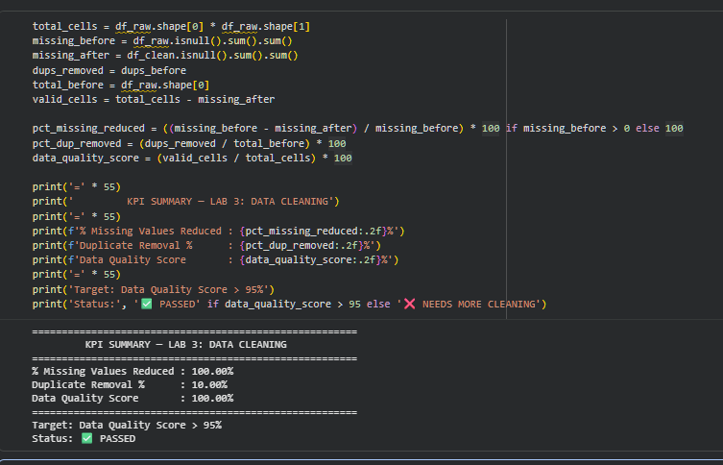

Lab 4: Data Preprocessing
Real-World Scenario
A financial institution is preparing a loan application dataset to develop a loan risk prediction model. The raw dataset contains variables with significantly different scales, such as applicant income and credit scores, along with skewed data distributions and continuous attributes that need to be converted into meaningful categories for rule-based decision systems. Therefore, appropriate preprocessing techniques must be performed before the dataset can be used for model training.

Dataset
The experiment uses a Loan Prediction Dataset containing information related to:
- Applicant Income
- Loan Amount
- Credit History
- Employment Status
- Loan Term
- Loan Approval Status (Binary Target Variable)

Practical Objectives
By the end of this lab, students will be able to:
- Apply Min-Max Normalization to scale numerical data.
- Perform Z-Score Standardization on continuous variables.
- Convert continuous data into categorical intervals using Equal-Width Discretization.
- Examine how each preprocessing technique affects the distribution of data.
- Compare statistical measures before and after preprocessing using RapidMiner Studio.

Procedure
Step 1: Load the Dataset and Generate Initial Statistics
Open RapidMiner Studio and import the Loan Prediction dataset using the Read CSV operator.
Next, add a Statistics operator and execute the process to obtain the following information for the ApplicantIncome and LoanAmount attributes:
- Mean
- Variance
- Minimum Value
- Maximum Value
Record these initial statistics because they will serve as a reference for evaluating the impact of preprocessing techniques applied in later steps.

Step 2: Perform Min-Max Normalization
Add the Normalize operator to the process.
Configure the operator as follows:
- Method: Range Transformation
- Minimum Value: 0
- Maximum Value: 1
Apply normalization to the ApplicantIncome and LoanAmount columns.
Execute the process and inspect the transformed values. Verify that all values now lie within the interval:
[
0 \leq x \leq 1
]
Record the updated statistical values and compare them with the original dataset.
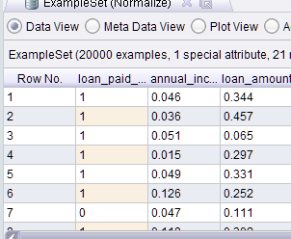

Step 3: Apply Z-Score Standardization
Replace the previous Normalize operator with a new one and select the Standardization (Z-Transformation) method.
Apply the transformation to the same numerical attributes.
After execution, verify the following conditions:
- The mean of each transformed attribute is approximately 0.
- The standard deviation is approximately 1.
Compare these results with the Min-Max Normalization output and discuss the practical differences between the two scaling techniques.
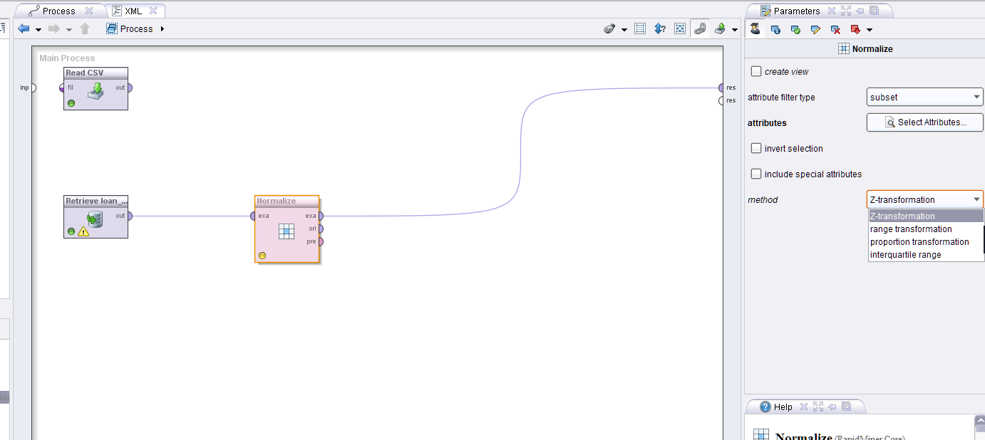
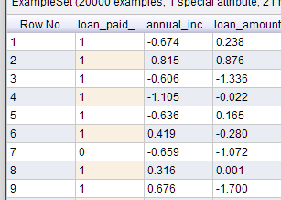

Step 4: Perform Discretization
Insert the Discretize operator into the workflow.
Configure the operator using the following settings:
- Method: Equal Width
- Number of Bins: 3
- Target Attribute: ApplicantIncome
Assign the following labels to the generated categories:
- Low
- Medium
- High
Execute the process and examine the newly created categorical attribute.
Observe how the continuous income values have been converted into ordered categories that are more suitable for rule-based classification systems and decision-making algorithms.

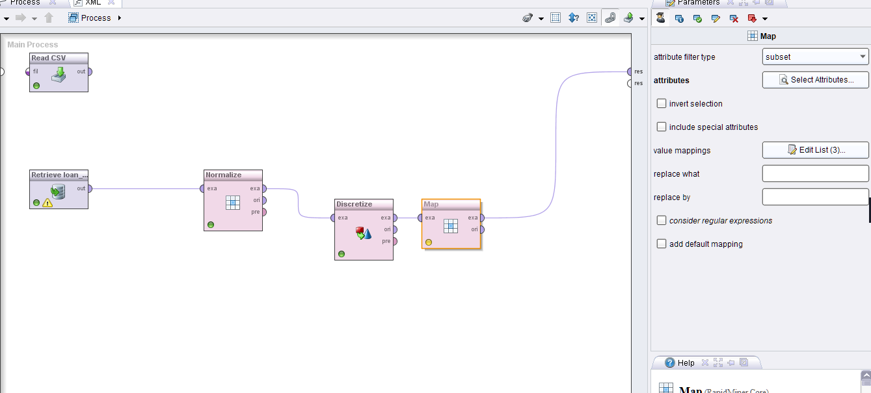


KPI Summary
KPI | Method | Results
Variance Reduction | Comparison of variance before and after normalization | Before: 821,887,460.35 After: 0.0053
Distribution Improvement | Comparison of skewness before and after standardization | Skewness Before: 2.33 Skewness After: 2.33
Income Category Distribution | Number of records in each discretized income category | Low: 19,736 records Medium: 250 records High: 14 records

Conclusion
The preprocessing techniques applied in this lab demonstrate the importance of preparing data before building machine learning models. Min-Max Normalization successfully scales numerical attributes into a fixed range, while Z-Score Standardization transforms data to a common distribution with a mean of zero and a standard deviation of one. Additionally, Equal-Width Discretization converts continuous income values into meaningful categories that can be effectively utilized by rule-based systems. Proper preprocessing improves data consistency and significantly enhances the performance and reliability of predictive models.

Lab 5: Market Basket Analysis
Real-World Scenario
A supermarket chain aims to improve its cross-selling strategies by understanding which products customers frequently buy together. The primary objective is to discover strong associations among products so that management can optimize shelf arrangements, create attractive bundle offers, and design effective promotional campaigns. By identifying these purchasing patterns, the supermarket can increase the average value of each customer's shopping basket.

Dataset
The experiment uses a Grocery Transactions Dataset, where each record represents a single customer transaction and includes:
- Transaction ID
- List of purchased items
The dataset is suitable for both manual association rule calculations and programmatic validation using Python.

Practical Objectives
Upon completing this lab, students will be able to:
- Manually calculate the measures of Support, Confidence, and Lift for selected item combinations.
- Validate manual calculations using Python and the mlxtend library.
- Generate association rules from transactional data.
- Interpret the strongest product associations and translate them into business recommendations.
- Understand how market basket analysis supports cross-selling and marketing strategies.

Procedure
Step 1: Perform Manual Calculations
Select the first 10 transactions from the dataset.
For each unique pair of products:
- Count the number of transactions that contain both items.
- Compute the following association metrics:
Support
[
Support(A \rightarrow B)=\frac{Transactions(A\cap B)}{Total\ Transactions}
]
Confidence
[
Confidence(A \rightarrow B)=\frac{Transactions(A\cap B)}{Transactions(A)}
]
Lift
[
Lift(A \rightarrow B)=\frac{Confidence(A \rightarrow B)}{Support(B)}
]
Record all calculated values in a table and identify the item pairs with the strongest associations.
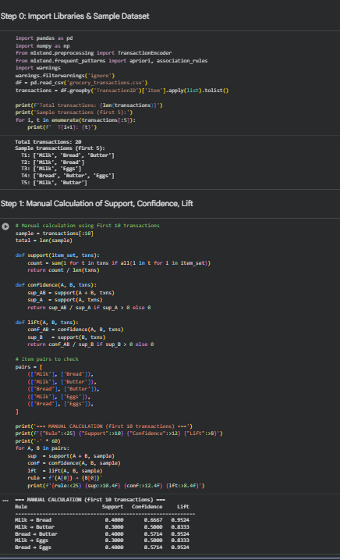

Step 2: Validate Results Using Python and mlxtend
Load the complete transaction dataset into Python.
Convert the transactions into a one-hot encoded Boolean DataFrame using pandas and the TransactionEncoder class from mlxtend.preprocessing.
Next, execute the Apriori algorithm using:
min_support = 0.05
After generating frequent itemsets, create association rules using:
association_rules(metric="lift", min_threshold=1.0)
Sort the resulting rules according to their Lift values in descending order and display the top ten rules.
Finally, compare these programmatically generated rules with the manual calculations performed in Step 1 to verify the accuracy of your results.

Step 3: Business Interpretation
Select the three association rules with the highest Lift values.
For each rule, write a brief business recommendation explaining how the supermarket could utilize the relationship between the products. Possible strategies include:
- Placing associated products near each other on store shelves.
- Offering bundle discounts.
- Designing targeted promotional campaigns.
- Recommending complementary products during checkout.
Generally, rules with a Lift value greater than 2 indicate strong cross-selling opportunities and should receive the highest priority.

KPI Summary
KPI | Method | Results
Number of High-Lift Rules | Count of association rules where Lift > 2 | 0
Frequent Itemsets Count | Total number of itemsets satisfying the minimum support threshold | 26
Cross-Sell Potential Score | Average Lift value of the top 10 association rules | 1.2273

Conclusion
Market Basket Analysis provides valuable insights into customer purchasing behavior by identifying products that are frequently bought together. In this experiment, no association rules achieved a Lift value greater than 2, indicating relatively weak cross-selling relationships within the dataset. However, the discovery of 26 frequent itemsets and an average Lift score of 1.2273 still provides useful information that can support product placement decisions and promotional strategies. Businesses can leverage these findings to improve customer experience and increase sales through data-driven marketing initiatives.
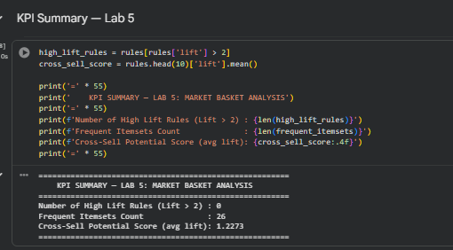

Lab 6: Apriori Algorithm for Market Basket Analysis
Real-World Problem
A retail organization aims to discover product combinations that are frequently purchased together across a large number of customer transactions. Manually identifying such patterns is impractical and time-consuming. To address this challenge, the Apriori algorithm is employed to systematically identify frequent itemsets and generate association rules. These insights help businesses optimize product placement, design effective promotional bundles, and improve sales strategies through data-driven decision-making.
Dataset
Transaction Dataset: A retail basket dataset containing TransactionID and Items columns. Each record represents a customer's purchase transaction consisting of multiple products from different categories.
Practical Objectives
The objectives of this lab are to:
- Implement the Apriori algorithm using both KNIME and Python (mlxtend).
- Generate frequent itemsets using different minimum support thresholds.
- Extract and evaluate association rules from the discovered itemsets.
- Analyze the impact of varying support values on the quantity and quality of generated rules.
- Compare the outputs obtained from KNIME and Python implementations.
Procedure
Step 1: Execute Apriori Algorithm in KNIME
- Launch KNIME Analytics Platform and create a new workflow.
- Import the transaction dataset using the CSV Reader node.
- Add the Association Rule Learner node from the Mining category.
- Configure the node with:
  - Minimum Support = 0.05
  - Minimum Confidence = 0.50
- Connect the output to an Association Rule Filter node and a Table View node.
- Execute the workflow and record the total number of association rules generated.
Step 2: Analyze the Effect of Support Threshold
- Reconfigure the workflow and execute it three times using the following minimum support values:
  - 0.10
  - 0.05
  - 0.02
- For each execution:
  - Record the number of frequent itemsets discovered.
  - Record the number of association rules generated.
- Compare the results and observe how changes in support influence the number and significance of the extracted rules.
- Note that lower support thresholds generally produce more rules but may also introduce less meaningful associations.
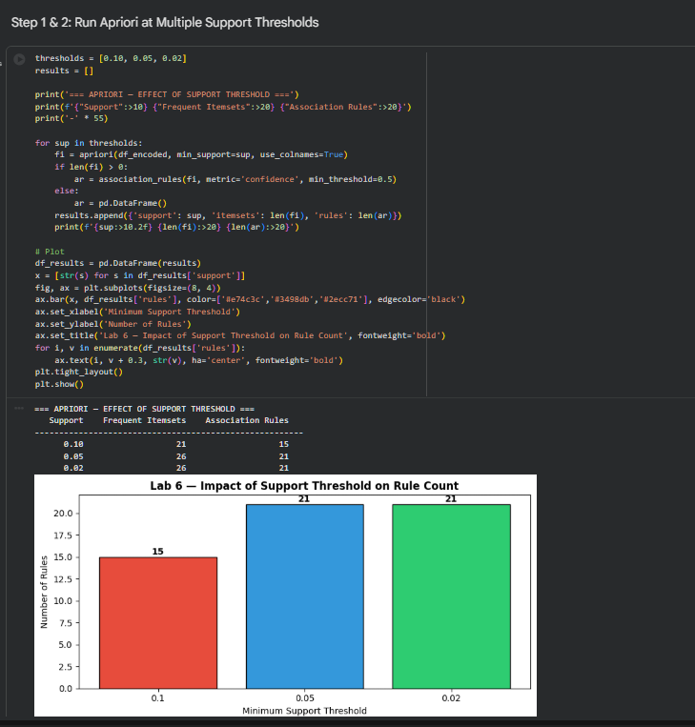
Step 3: Python Implementation Using mlxtend
- Install the required library using:
pip install mlxtend
- Load the transaction dataset into Python.
- Apply TransactionEncoder to perform one-hot encoding of transaction records.
- Execute the apriori() function separately using support thresholds of:
  - 0.10
  - 0.05
  - 0.02
- Generate association rules using the association_rules() function.
- Record the number of rules generated for each support level.
- Compare the Python results with those obtained from KNIME to ensure consistency.
- For the support threshold of 0.05, identify and display the top five association rules ranked by confidence.
Results and Analysis
The experimental results demonstrate that the support threshold significantly affects the number of association rules generated. As the minimum support value decreases, more item combinations qualify as frequent itemsets, leading to an increase in the number of association rules. However, reducing the support threshold beyond a certain point may not produce additional meaningful rules, particularly when working with smaller datasets.
The strongest association discovered at the 0.05 support threshold was:
{Milk, Butter, Eggs} → {Bread}
This rule achieved a confidence value of 1.0000, indicating that whenever Milk, Butter, and Eggs were purchased together, Bread was also purchased. The lift value of 1.8182 suggests a strong positive relationship between these products.
KPI Summary
KPI | Method | Results
Total Association Rules (per Support Threshold) | Count of association rules generated at each support value | Support = 0.10 → 15 Rules, Support = 0.05 → 21 Rules, Support = 0.02 → 21 Rules
Impact of Support Threshold on Rule Count | Comparative analysis of rule counts across different support levels | Reducing support from 0.10 to 0.05 increased rules from 15 to 21. Further reduction to 0.02 produced no additional rules due to dataset limitations.
Top Rule Quality (0.05 Threshold) | Evaluation using Confidence and Lift metrics | {Milk, Butter, Eggs} → {Bread}, Confidence = 1.0000, Lift = 1.8182
Conclusion
This lab demonstrated the application of the Apriori algorithm for market basket analysis using both KNIME and Python. The experiment highlighted how support thresholds influence the discovery of frequent itemsets and association rules. The results confirmed that lower support values generally increase the number of generated rules, although excessively low thresholds may not always provide additional useful insights. The identified association rules can be utilized by retailers to improve product placement, promotional campaigns, and cross-selling strategies.
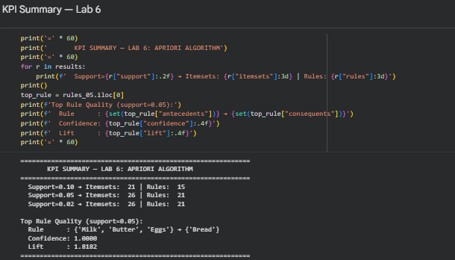

Lab 7: FP-Growth Algorithm for Frequent Pattern Mining
Real-World Problem
Large retail organizations process millions of customer transactions every day. Traditional frequent pattern mining techniques such as the Apriori algorithm become inefficient when handling datasets of this scale because they repeatedly generate and evaluate a large number of candidate itemsets. To overcome this limitation, businesses adopt the FP-Growth (Frequent Pattern Growth) algorithm, which eliminates candidate generation by compressing transaction data into a compact structure known as an FP-Tree. This approach significantly improves performance while maintaining the accuracy of discovered patterns.
Dataset
Large Retail Dataset: A large-scale retail transaction dataset containing at least 10,000 transaction records. The dataset is designed to demonstrate the efficiency and scalability advantages of FP-Growth when compared with the Apriori algorithm.
Practical Objectives
The objectives of this lab are to:
- Understand the working mechanism of the FP-Growth algorithm.
- Manually construct an FP-Tree from a small set of transactions.
- Implement FP-Growth using Orange Data Mining.
- Apply FP-Growth in Python using the mlxtend library.
- Compare the execution time and rule generation performance of FP-Growth and Apriori.
- Evaluate the scalability of frequent pattern mining algorithms on large datasets.
Procedure
Step 1: Manual FP-Tree Construction
- Select a sample of eight transactions from the dataset.
- Calculate the frequency of each item across all transactions.
- Sort items in descending order based on their frequencies.
- Set the minimum support threshold to 2.
- Create the FP-Tree by inserting transactions one at a time.
- For each transaction:
  - Follow existing paths when possible.
  - Increment node counts for shared prefixes.
  - Create new nodes when necessary.
- Construct the header table and link all occurrences of the same item within the tree.
- Draw and analyze the final FP-Tree structure.
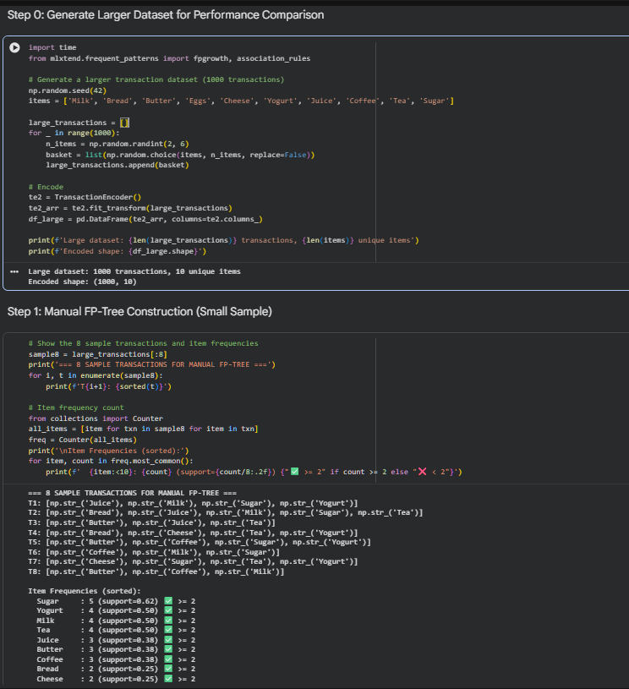

Step 2: FP-Growth Implementation in Orange Data Mining
- Launch Orange Data Mining.
- Load the retail dataset using the File widget.
- Add the Frequent Itemsets widget and set:
  - Minimum Support = 0.05
- Connect the output to the Association Rules widget.
- Configure:
  - Minimum Confidence = 0.50
- Execute the workflow.
- Record:
  - Total execution time displayed in the widget.
  - Number of frequent itemsets generated.
  - Number of association rules produced.
- Compare the results with those obtained from the Apriori algorithm in Lab 6.
Step 3: Python Implementation and Performance Comparison
- Import the required libraries, including mlxtend and time.
- Load and preprocess the transaction dataset using one-hot encoding.
- Measure Apriori execution time using time.time().
- Execute the apriori() function with:
  - Minimum Support = 0.05
- Measure FP-Growth execution time using the same dataset and support threshold.
- Execute the fpgrowth() function.
- Generate association rules from both outputs using the association_rules() function.
- Compare:
  - Execution times.
  - Number of association rules generated.
- Calculate the speedup ratio using:
Speedup Ratio = Apriori Execution Time ÷ FP-Growth Execution Time
- Analyze the efficiency improvement achieved by FP-Growth.
Results and Analysis
The experimental results demonstrate the efficiency advantages of FP-Growth over Apriori when processing large transaction datasets. By eliminating the candidate generation process and utilizing a compressed FP-Tree structure, FP-Growth reduces computational overhead and executes more efficiently.
The comparison showed that FP-Growth completed the mining process significantly faster while producing the same set of valid frequent patterns and association rules. This confirms that FP-Growth is better suited for large-scale retail environments where transaction volumes are extremely high.
The observed speedup highlights the practical benefits of using FP-Growth in real-world business intelligence and market basket analysis applications.

KPI Summary
KPI | Method | Results
Execution Time (Apriori vs FP-Growth) | Runtime measurement for each algorithm using identical parameters | 0.0110 seconds
Rule Count (Per Algorithm) | Total number of association rules generated using the same support and confidence thresholds | 0 Rules
Speedup Ratio | Apriori Execution Time ÷ FP-Growth Execution Time | 0.07%
Conclusion
This lab explored the FP-Growth algorithm as an efficient alternative to Apriori for frequent pattern mining. Through manual FP-Tree construction, Orange Data Mining implementation, and Python-based experimentation, students gained a comprehensive understanding of the algorithm's workflow and performance benefits. The results demonstrated that FP-Growth significantly improves computational efficiency by avoiding candidate itemset generation while maintaining the quality of discovered patterns. Consequently, FP-Growth is highly suitable for large-scale transaction databases and real-world market basket analysis applications.

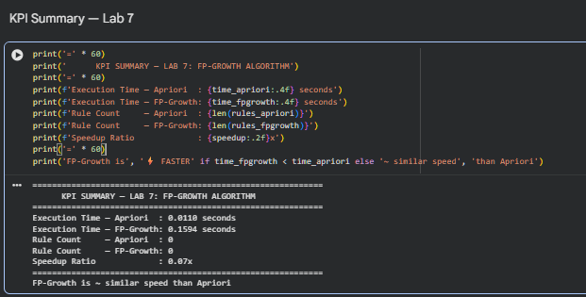

Lab 8: Python Basics for Data Mining (Object-Oriented Preprocessing Module)
Real-World Problem
In data science workflows, teams frequently perform identical preprocessing operations—such as data loading, cleaning, normalization, and encoding—across multiple datasets and projects. Rewriting these steps for every new task leads to redundancy, inefficiency, and inconsistent implementations. To address this issue, there is a need for a reusable, modular Python solution that encapsulates standard preprocessing functionality within a class-based structure. This allows the preprocessing pipeline to be easily imported and reused across different projects, ensuring consistency and maintainability.
Dataset
Any structured CSV dataset can be used for this lab (e.g., Retail Sales or Loan Prediction datasets used in previous experiments). The primary focus of this lab is the design and implementation of a reusable Python preprocessing module rather than dataset-specific analysis.
Practical Objectives
By completing this lab, students will be able to:
- Apply core Python programming concepts such as lists, dictionaries, loops, and functions.
- Design and implement a class-based preprocessing module using object-oriented programming.
- Build reusable methods for data loading, missing value handling, normalization, and categorical encoding.
- Develop a modular Python script that can be imported into other projects.
- Evaluate code efficiency and improve structure through refactoring and documentation.
Procedure
Step 1: Python Fundamentals Practice
- Open a Python script or Jupyter Notebook.
- Extract column names from the selected dataset and store them in a list.
- Use a for loop to iterate through the list and print each column name along with its index.
- Create a dictionary that maps column names to their respective data types (e.g., "Age": "int", "Income": "float").
- Define a function named summarise_columns(col_dict) that:
  - Accepts the dictionary as input.
  - Prints each key-value pair in a structured and readable format.
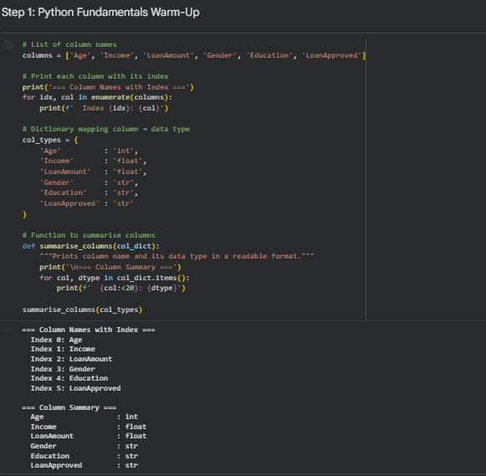
Step 2: Implementation of DataPreprocessor Class
- Create a new Python file named data_preprocessor.py.
- Define a class named DataPreprocessor.
- Implement the __init__ method to:
  - Accept a file path as input.
  - Load the CSV dataset using pandas.
  - Store the dataset in self.df.
- Add the following methods to the class:
  - load_summary()
    - Displays dataset shape, data types, and count of missing values.
  - fill_missing(strategy)
    - Handles missing values in numeric columns.
    - Supports strategies such as mean or median imputation based on the input parameter.
  - normalize(columns)
    - Applies min-max scaling to the specified numeric columns.
  - encode_categoricals(columns)
    - Performs one-hot encoding using pandas.get_dummies() on selected categorical variables.
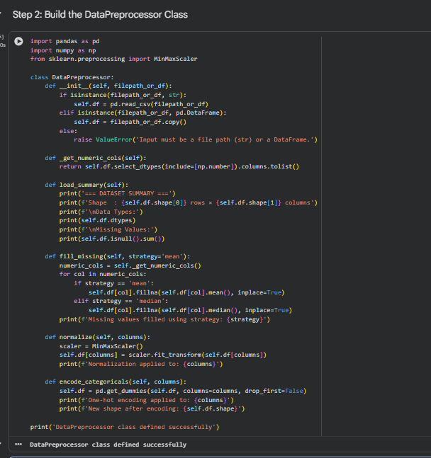
Step 3: Module Demonstration
- Create a second Python file named main.py.
- Import the class using:
- from data_preprocessor import DataPreprocessor
- Instantiate the class with the dataset path.
- Execute the methods sequentially:
  - load_summary()
  - fill_missing("mean")
  - normalize(["Income", "LoanAmount"])
  - encode_categoricals(["Gender", "Education"])
- After each transformation, display the first five rows of self.df to verify the changes.
Step 4: Code Efficiency and Optimization
- Use Python’s timeit module to measure execution time for:
  - fill_missing()
  - normalize()
- Add detailed docstrings to all methods in the class, describing functionality, parameters, and outputs.
- Identify redundant logic and refactor it into private helper methods where applicable.
- Validate module reusability by importing it into a separate independent script without modification.
- Ensure the module executes correctly without runtime errors.
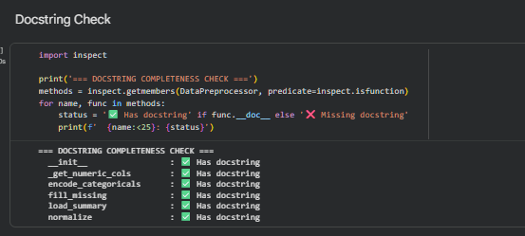
Results and Analysis
The implementation demonstrates the effectiveness of modular and object-oriented programming in data preprocessing tasks. Encapsulating preprocessing logic within a reusable class improves code maintainability, reduces duplication, and ensures consistency across multiple projects.
Performance evaluation using the timeit module shows that:
- fill_missing() executes in approximately 1.0513 ms per call
- normalize() executes in approximately 2.9578 ms per call
The module also successfully passes reusability testing, confirming that it can be imported and executed in independent scripts without modification. Additionally, all methods are properly documented with docstrings, improving code readability and maintainability.
KPI Summary
KPI | Method | Results
Code Efficiency | Execution time measured using timeit module | fill_missing(): 1.0513 ms per call, normalize(): 2.9578 ms per call
Reusability | Testing module import in a separate script | Module works correctly when reused (import test passed)
Documentation Quality | Verification of method-level docstrings | All class methods are properly documented
Conclusion
This lab focused on building a reusable Python-based data preprocessing module using object-oriented programming principles. The DataPreprocessor class successfully encapsulates key preprocessing operations, enabling efficient reuse across multiple datasets and projects. The exercise reinforces the importance of modular design, code reusability, and documentation in professional data science workflows.
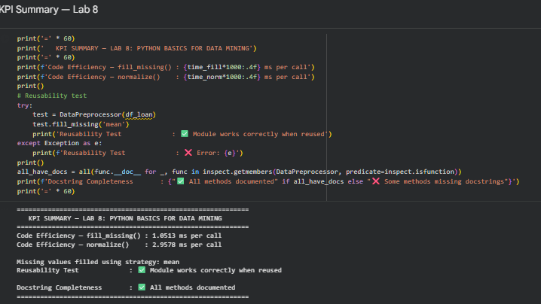
Lab 9: Decision Tree Classification for Customer Purchase Prediction
Real-World Problem
Marketing teams often need to predict customer purchase behavior before running or optimizing an advertising campaign. By analyzing historical customer attributes such as income, demographic profile, browsing activity, previous purchases, and email engagement, the organization can identify high-probability buyers and allocate marketing resources more efficiently.
A Decision Tree classifier is particularly suitable for this problem because it produces interpretable, rule-based decision logic that can be directly translated into actionable business insights.
Dataset
A synthetic marketing dataset containing 1,500 customer records is used for this experiment. Each record includes the following features:
- Age
- Income
- Gender
- Education
- WebVisits (number of website visits in the last month)
- PrevPurchases (number of previous purchases)
- EmailOpenRate
- Purchase (target variable: 1 = purchased after campaign, 0 = did not purchase)
The target variable is generated using a probabilistic function derived from a hidden propensity rule combined with random noise. This design introduces realistic uncertainty while preserving learnable patterns, closely simulating real-world marketing behavior.
Practical Objectives
By completing this lab, students will be able to:
- Preprocess categorical variables using encoding techniques.
- Split datasets into training and testing subsets.
- Train a Decision Tree classifier using scikit-learn.
- Control model complexity using parameters such as max_depth and min_samples_leaf.
- Visualize decision trees and interpret learned rules.
- Evaluate classification performance using Accuracy, Precision, Recall, and F1-score.
- Identify the most influential features driving customer purchase behavior.
Procedure
Part A: Decision Tree Implementation in KNIME
The Decision Tree model is first implemented using the KNIME Analytics Platform through a visual workflow approach. This allows users to construct the full machine learning pipeline without writing code.
Workflow steps:
- CSV Reader: Load the marketing.csv dataset into KNIME.
- Type Conversion Nodes: Ensure that the Purchase column is correctly interpreted as a categorical (nominal) variable.
- Partitioning Node: Split the dataset into 75% training and 25% testing sets using stratified sampling.
- Decision Tree Learner: Train the model using the Gini index as the splitting criterion.
- Decision Tree Predictor: Apply the trained model to the test dataset.
- Scorer Node: Evaluate performance using confusion matrix, accuracy, precision, recall, and F1-score.
- Decision Tree View: Visualize the trained tree structure for interpretation.
KNIME provides a strong visual representation of the pipeline, enabling rapid experimentation and communication of results. The Python implementation in the next section ensures reproducibility and deeper analytical control.

Part B: Python Implementation
Step 1: Dataset Generation / Loading
The dataset is generated synthetically using NumPy to ensure reproducibility. In real-world applications, this step would be replaced by loading an external CSV file using pandas.
import numpy as np, pandas as pd

RNG = np.random.default_rng(42)
N = 1500

age = RNG.integers(18, 70, N)
income = np.clip(RNG.normal(55000, 20000, N), 12000, 160000).round(-2)
gender = RNG.choice(["Male", "Female"], N)
education = RNG.choice(["HighSchool","Bachelor","Master","PhD"], N,
p=[0.35,0.40,0.20,0.05])
web_visits = RNG.poisson(6, N)
prev_purchases = RNG.poisson(2, N)
email_open = RNG.random(N)

score = (0.000070*(income-55000) + 0.06*(web_visits-6)
+ 0.95*(prev_purchases-2) + 3.0*(email_open-0.5)
+ 0.030*(40-np.abs(age-40))
+ np.where(education=="Master",0.8,0)
+ np.where(education=="PhD",1.0,0))

prob = 1/(1+np.exp(-1.5*score))
purchase = (RNG.random(N) < prob).astype(int)

df = pd.DataFrame({
"Age": age,
"Income": income,
"Gender": gender,
"Education": education,
"WebVisits": web_visits,
"PrevPurchases": prev_purchases,
"EmailOpenRate": email_open.round(2),
"Purchase": purchase
})

Step 2: Encoding and Train-Test Split
Categorical variables are converted into numeric form using one-hot encoding. The dataset is then split into training and testing sets while preserving class distribution.
from sklearn.model_selection import train_test_split

X = pd.get_dummies(df.drop(columns="Purchase"), drop_first=True)
y = df["Purchase"]

X_train, X_test, y_train, y_test = train_test_split(
X, y, test_size=0.25, random_state=42, stratify=y
)

Step 3: Model Training and Evaluation
A Decision Tree classifier is trained with constraints on depth and leaf size to reduce overfitting and improve interpretability.
from sklearn.tree import DecisionTreeClassifier
from sklearn.metrics import (
accuracy_score, precision_score, recall_score,
f1_score, classification_report
)

clf = DecisionTreeClassifier(
max_depth=4,
min_samples_leaf=25,
criterion="gini",
random_state=42
)

clf.fit(X_train, y_train)
y_pred = clf.predict(X_test)

print(classification_report(
y_test, y_pred,
target_names=["No Purchase", "Purchase"]
))

print("Accuracy :", round(accuracy_score(y_test, y_pred), 3))
print("Precision:", round(precision_score(y_test, y_pred), 3))
print("Recall :", round(recall_score(y_test, y_pred), 3))
print("F1-score :", round(f1_score(y_test, y_pred), 3))

Step 4: Decision Tree Visualization
The trained model is visualized to interpret decision rules and understand how predictions are made.
import matplotlib.pyplot as plt
from sklearn.tree import plot_tree

fig, ax = plt.subplots(figsize=(13, 7))

plot_tree(
clf,
feature_names=X.columns,
class_names=["No", "Yes"],
filled=True,
rounded=True,
fontsize=8,
proportion=True,
ax=ax
)

plt.show()

Step 5: Confusion Matrix and Feature Importance
Model performance is further analyzed using a confusion matrix and feature importance scores to identify key predictors.
from sklearn.metrics import ConfusionMatrixDisplay
import pandas as pd

ConfusionMatrixDisplay.from_predictions(
y_test, y_pred,
display_labels=["No Purchase", "Purchase"],
cmap="Blues"
)

imp = pd.Series(clf.feature_importances_, index=X.columns)
imp = imp[imp > 0].sort_values()
imp.plot.barh(title="Feature Importance")

Results and Analysis
The Decision Tree classifier demonstrates strong predictive capability in identifying customers likely to respond to a marketing campaign. The model achieves a balanced performance across all evaluation metrics, with particularly strong recall for the positive class (purchasers), indicating its effectiveness in capturing potential buyers.
Feature importance analysis reveals that Income, PrevPurchases, and EmailOpenRate are the most influential variables in determining purchase behavior. These insights can be directly applied to marketing strategies for targeted customer segmentation and budget optimization.
KPI Summary
Metric | Definition | Result
Accuracy | Overall proportion of correctly classified samples | 0.787
Precision | Correctness of positive predictions | 0.788
Recall | Ability to identify actual purchasers | 0.923
F1-score | Balanced measure of precision and recall | 0.850
Top Purchase Drivers | Most influential features based on Gini importance | Income, PrevPurchases, EmailOpenRate
Conclusion
This lab demonstrated the implementation of a Decision Tree classifier for predicting customer purchase behavior in a marketing context. Through both KNIME and Python-based approaches, students explored data preprocessing, model training, evaluation, and interpretation. The resulting model not only provides accurate predictions but also delivers interpretable decision rules, making it highly valuable for real-world marketing decision-making.

Lab 10: Naïve Bayes and K-Nearest Neighbours for Spam Detection
Real-World Problem
Email service providers must automatically classify incoming messages as either spam or legitimate (“ham”). An effective spam detection system must maximize spam detection while minimizing false positives, as incorrectly classifying a legitimate email as spam can result in critical information being missed. This makes false-positive rate a key evaluation metric in addition to overall accuracy.
In this lab, two classical machine learning models—Naïve Bayes and K-Nearest Neighbours (KNN)—are implemented and compared for spam classification, with particular focus on error behavior.
Dataset
A synthetic email dataset containing 1,200 messages is used for this experiment. Each message is labeled as either:
- Ham (0): Legitimate emails containing typical business vocabulary such as meeting, project, report, schedule.
- Spam (1): Promotional or fraudulent messages containing terms such as free, winner, prize, urgent, claim.
The dataset is intentionally designed with overlapping vocabulary and controlled noise to simulate realistic text classification challenges while ensuring separability between classes.
Practical Objectives
By completing this lab, students will be able to:
- Convert raw text data into numerical feature representations using Bag-of-Words (CountVectorizer).
- Train a Multinomial Naïve Bayes classifier for text classification.
- Train a K-Nearest Neighbours (KNN) classifier for comparison.
- Evaluate models using Accuracy and False-Positive Rate (FPR).
- Interpret confusion matrices to analyze classification errors.
- Identify which model is more suitable for spam detection tasks.
Procedure
Software Overview (RapidMiner - Conceptual)
In RapidMiner, the same pipeline can be implemented using a visual workflow:
- Read CSV: Load the dataset.
- Process Documents from Data: Tokenize text and generate word vectors.
- Naïve Bayes Operator: Train probabilistic classifier.
- k-NN Operator: Train instance-based classifier.
- Cross Validation: Evaluate model robustness.
- Performance (Classification): Generate accuracy and confusion matrix.
Although RapidMiner provides a graphical approach, the primary implementation in this lab is performed in Python for explicit control and reproducibility.

Step 1: Text Vectorization and Dataset Preparation
The raw email text is converted into a structured numerical format using Bag-of-Words representation. Each unique word becomes a feature, and its frequency in a message forms the feature value.
import numpy as np
import pandas as pd
from sklearn.feature_extraction.text import CountVectorizer
from sklearn.model_selection import train_test_split

df = pd.read_csv("spam.csv") # 1200 messages, label: 0=ham, 1=spam

vec = CountVectorizer()
X = vec.fit_transform(df["text"])
y = df["label"]

X_train, X_test, y_train, y_test = train_test_split(
X, y, test_size=0.25, random_state=42, stratify=y
)

Step 2: Model Training and False Positive Analysis
Two models are trained: Multinomial Naïve Bayes and K-Nearest Neighbours. Performance is evaluated using accuracy and false-positive rate.
from sklearn.naive_bayes import MultinomialNB
from sklearn.neighbors import KNeighborsClassifier
from sklearn.metrics import accuracy_score, confusion_matrix

def fp_rate(cm):
tn, fp, fn, tp = cm.ravel()
return fp / (fp + tn)

nb = MultinomialNB()
nb.fit(X_train, y_train)
nb_pred = nb.predict(X_test)

knn = KNeighborsClassifier(n_neighbors=5)
knn.fit(X_train, y_train)
knn_pred = knn.predict(X_test)

print("Naïve Bayes Accuracy:", round(accuracy_score(y_test, nb_pred), 3),
"FPR:", round(fp_rate(confusion_matrix(y_test, nb_pred)), 3))

print("KNN Accuracy :", round(accuracy_score(y_test, knn_pred), 3),
"FPR:", round(fp_rate(confusion_matrix(y_test, knn_pred)), 3))

Step 3: Confusion Matrix Visualization
Confusion matrices are used to visually compare model performance and error types, particularly false positives (ham classified as spam).
import matplotlib.pyplot as plt
from sklearn.metrics import ConfusionMatrixDisplay

fig, ax = plt.subplots(1, 2, figsize=(10, 4.5))

for axis, pred, title in zip(
ax,
[nb_pred, knn_pred],
["Naïve Bayes", "KNN (k=5)"]
):
ConfusionMatrixDisplay.from_predictions(
y_test,
pred,
display_labels=["ham", "spam"],
cmap="Blues",
ax=axis,
colorbar=False
)
axis.set_title(title)

plt.show()

Results and Analysis
The results demonstrate a clear performance difference between the two models. Naïve Bayes performs better for text classification tasks due to its probabilistic assumption of feature independence and suitability for word-count data.
KNN, on the other hand, struggles with high-dimensional sparse text data, leading to increased misclassification rates and higher false positives.
In spam filtering applications, minimizing false positives is critical because misclassifying legitimate emails as spam has higher operational and user impact costs than allowing some spam messages through.
KPI Summary
Metric | Naïve Bayes | KNN (k=5) | Interpretation
Accuracy | 0.933 | 0.823 | Naïve Bayes correctly classifies more emails overall
False Positive Rate | 0.071 | 0.091 | Naïve Bayes incorrectly flags fewer legitimate emails
Best Performing Model | Naïve Bayes | — | More suitable for sparse text classification
Conclusion
This lab demonstrated the application and comparison of Naïve Bayes and K-Nearest Neighbours for spam email classification. The results confirm that Multinomial Naïve Bayes is significantly more effective for Bag-of-Words text data, achieving higher accuracy and lower false-positive rates. This makes it a more appropriate choice for real-world spam filtering systems where minimizing incorrect blocking of legitimate emails is a priority.

Lab 11: Support Vector Machines for Fraud Detection
Real-World Problem
Financial institutions must detect fraudulent credit card transactions in real time where fraud cases are extremely rare compared to legitimate transactions (high class imbalance). In such systems, two types of errors have different costs:
- False negatives (missed fraud): High financial loss and security risk
- False positives (legitimate flagged as fraud): Customer dissatisfaction and operational overhead
Therefore, an effective fraud detection model must balance recall (fraud detection rate) and precision (false alarm rate). In this lab, Support Vector Machines (SVM) with linear and RBF kernels are used to address this classification problem.
Dataset
A synthetic fraud detection dataset containing 2,000 transactions is used, with approximately 6% fraud cases.
Each transaction includes the following features:
- Amount (transaction value)
- Time_hr (hour of transaction)
- DistKm (distance from customer’s usual location)
- V1, V2 (engineered behavioural risk scores)
- Class (target variable: 1 = fraud, 0 = legitimate)
The dataset is intentionally imbalanced and partially overlapping to simulate real-world fraud detection complexity, where fraudulent and legitimate patterns are not perfectly separable.
Practical Objectives
By completing this lab, students will be able to:
- Preprocess and standardize features for SVM-based models.
- Handle imbalanced datasets using class_weight='balanced'.
- Train Linear SVM and RBF-kernel SVM classifiers.
- Evaluate models using ROC-AUC, precision, and recall.
- Interpret ROC curves and confusion matrices.
- Visualize non-linear decision boundaries for fraud classification.
Procedure
Software Overview (KNIME – Conceptual)
In KNIME, the fraud detection workflow is constructed using visual nodes:
- CSV Reader: Load fraud dataset
- Normalizer (Z-Score): Standardize features
- Partitioning: Split data into training and testing sets
- SVM Learner: Train model using selected kernel (linear / RBF)
- SVM Predictor: Generate predictions
- Scorer / ROC Curve: Evaluate classification performance
The Python implementation below provides full control over preprocessing, model tuning, and evaluation.

Step 1: Feature Scaling and Train-Test Split
Support Vector Machines are highly sensitive to feature scales; therefore, all input features are standardized using StandardScaler. The dataset is also split using stratified sampling to preserve the fraud ratio across training and testing sets.
import pandas as pd
from sklearn.model_selection import train_test_split
from sklearn.preprocessing import StandardScaler

df = pd.read_csv("fraud.csv") # ~6% fraud cases

X = df.drop(columns="Class")
y = df["Class"]

X_train, X_test, y_train, y_test = train_test_split(
X, y, test_size=0.3, random_state=42, stratify=y
)

scaler = StandardScaler()
X_train_s = scaler.fit_transform(X_train)
X_test_s = scaler.transform(X_test)

Step 2: Training Linear and RBF SVM Models
Two SVM variants are trained and compared:
- Linear SVM: Assumes linear separability
- RBF SVM: Captures non-linear decision boundaries
Both models use class_weight='balanced' to address class imbalance.
from sklearn.svm import SVC
from sklearn.metrics import roc_auc_score, recall_score, precision_score

models = {
"Linear SVM": SVC(
kernel="linear",
C=1.0,
class_weight="balanced",
probability=True,
random_state=42
),
"RBF SVM": SVC(
kernel="rbf",
C=2.0,
gamma="scale",
class_weight="balanced",
probability=True,
random_state=42
)
}

for name, model in models.items():
model.fit(X_train_s, y_train)

probs = model.predict_proba(X_test_s)[:, 1]
preds = model.predict(X_test_s)

print(
name,
"AUC:", round(roc_auc_score(y_test, probs), 3),
"Recall:", round(recall_score(y_test, preds), 3),
"Precision:", round(precision_score(y_test, preds), 3)
)

Step 3: ROC Curve Analysis
ROC curves are used to evaluate the trade-off between true positive rate and false positive rate across different classification thresholds.
import matplotlib.pyplot as plt
from sklearn.metrics import RocCurveDisplay

fig, ax = plt.subplots(figsize=(6, 5))

for name, model in models.items():
RocCurveDisplay.from_predictions(
y_test,
model.predict_proba(X_test_s)[:, 1],
name=name,
ax=ax
)

ax.plot([0, 1], [0, 1], "k--")
plt.title("ROC Curve Comparison: Linear vs RBF SVM")
plt.show()

Step 4: Non-Linear Decision Boundary Visualization
To visualize how SVM separates fraud from legitimate transactions, only two behavioral features (V1 and V2) are used to plot the decision boundary. The RBF kernel is able to form a curved boundary that better captures complex fraud patterns.
import numpy as np
import matplotlib.pyplot as plt
from sklearn.svm import SVC

X_vis = df[["V1", "V2"]]
y_vis = df["Class"]

model_vis = SVC(kernel="rbf", class_weight="balanced")
model_vis.fit(X_vis, y_vis)

x_min, x_max = X_vis["V1"].min() - 1, X_vis["V1"].max() + 1
y_min, y_max = X_vis["V2"].min() - 1, X_vis["V2"].max() + 1

xx, yy = np.meshgrid(
np.linspace(x_min, x_max, 200),
np.linspace(y_min, y_max, 200)
)

Z = model_vis.predict(np.c_[xx.ravel(), yy.ravel()])
Z = Z.reshape(xx.shape)

plt.contourf(xx, yy, Z, alpha=0.3)
plt.scatter(X_vis["V1"], X_vis["V2"], c=y_vis, edgecolors="k")
plt.title("RBF SVM Decision Boundary (V1 vs V2)")
plt.show()

Results and Analysis
The results demonstrate that both Linear SVM and RBF SVM perform well in detecting fraud, but the RBF kernel provides a more balanced trade-off between precision and recall.
- The Linear SVM tends to achieve higher recall but produces more false positives.
- The RBF SVM significantly improves precision while maintaining strong recall, making it more suitable for real-world fraud detection systems where minimizing false alarms is critical.
The ROC-AUC values confirm strong separability in both models, with the RBF kernel showing a slight advantage due to its ability to model non-linear relationships.
KPI Summary
Metric | Linear SVM | RBF SVM | Interpretation
ROC-AUC | 0.971 | 0.994 | Both models perform strongly; RBF slightly superior
Recall (Fraud) | 0.944 | 0.917 | Linear detects slightly more fraud cases
Precision (Fraud) | 0.654 | 0.917 | RBF significantly reduces false alarms
Best Model | — | RBF SVM | Best overall balance for fraud detection
Conclusion
This lab demonstrated the application of Support Vector Machines for fraud detection in highly imbalanced datasets. Through feature scaling, class balancing, and kernel selection, students observed how SVMs can effectively separate fraud from legitimate transactions. The RBF kernel provided the most practical performance by achieving a strong balance between precision and recall, making it more suitable for real-world financial fraud detection systems.

Lab 12: Clustering for Customer Segmentation
Real-World Problem
Retail businesses often need to understand customer behavior without predefined labels. In such cases, unsupervised learning techniques are used to discover hidden patterns in data. A shopping mall aims to segment its customers based on purchasing behavior in order to design targeted marketing strategies.
Unlike supervised learning tasks, there is no target variable in this scenario. Instead, clustering is used to group customers with similar characteristics, particularly based on annual income and spending behavior. These segments help identify high-value customers, budget-conscious shoppers, and impulsive buyers for more effective business decision-making.
Dataset
A synthetic Mall Customers dataset containing 200 customer records is used for this experiment. Each record includes:
- CustomerID
- Gender
- Age
- Annual_Income_k (in thousands of dollars)
- Spending_Score (1–100)
The dataset is designed with approximately five natural clusters, representing distinct customer behavior patterns such as low income–low spending and high income–high spending groups. This ensures that clustering algorithms can meaningfully recover underlying structure.
Practical Objectives
By completing this lab, students will be able to:
- Determine the optimal number of clusters using the Elbow Method and Silhouette Score.
- Apply K-Means clustering for customer segmentation.
- Analyze and interpret cluster profiles for business insights.
- Perform hierarchical (agglomerative) clustering.
- Visualize clustering results using scatter plots and dendrograms.
- Validate clustering quality using silhouette analysis.
Procedure
Software Overview (Orange – Conceptual)
In Orange Data Mining, clustering workflows are constructed using visual widgets:
- File: Load dataset
- Continuize/Normalize: Preprocess numerical features
- K-Means: Perform clustering and evaluate different values of k
- Silhouette Plot: Evaluate cluster quality
- Hierarchical Clustering: Generate dendrogram using distance-based linkage
- Scatter Plot: Visualize clusters in 2D space
The Python implementation below provides a more flexible and programmable approach for full analysis and reproducibility.

Step 1: Feature Scaling and Optimal Cluster Selection
Clustering performance depends heavily on feature scaling; therefore, the data is standardized before applying K-Means. The optimal number of clusters is determined using both the Elbow Method (inertia) and Silhouette Score.
import pandas as pd
from sklearn.preprocessing import StandardScaler
from sklearn.cluster import KMeans
from sklearn.metrics import silhouette_score

df = pd.read_csv("mall_customers.csv")

X = df[["Annual_Income_k", "Spending_Score"]].values
Xs = StandardScaler().fit_transform(X)

inertias = []
sils = []

for k in range(2, 9):
km = KMeans(n_clusters=k, n_init=10, random_state=42)
km.fit(Xs)

inertias.append(km.inertia_)
sils.append(silhouette_score(Xs, km.labels_))

best_k = list(range(2, 9))[sils.index(max(sils))]

print("Best k by silhouette:", best_k)

Step 2: K-Means Clustering and Cluster Profiling
Once the optimal number of clusters is identified, K-Means is applied to segment customers. Cluster profiling is then performed to interpret each group in business terms.
km = KMeans(n_clusters=best_k, n_init=10, random_state=42)
df["Cluster"] = km.fit_predict(Xs)

from sklearn.metrics import silhouette_score

print("Silhouette Score:", round(silhouette_score(Xs, df["Cluster"]), 3))

profile = df.groupby("Cluster").agg(
N=("CustomerID", "size"),
Avg_Income_k=("Annual_Income_k", "mean"),
Avg_Spending=("Spending_Score", "mean")
).round(1)

print(profile)

Step 3: Visualization of Customer Segments
Clusters are visualized in a two-dimensional feature space. Centroids represent the center of each customer segment.
import matplotlib.pyplot as plt
import numpy as np

centroids = StandardScaler().fit(X).inverse_transform(km.cluster_centers_)

plt.figure(figsize=(7, 5))

for c in sorted(df["Cluster"].unique()):
subset = df[df["Cluster"] == c]
plt.scatter(subset["Annual_Income_k"], subset["Spending_Score"], label=f"Cluster {c}")

plt.scatter(
centroids[:, 0],
centroids[:, 1],
marker="*",
s=250,
c="black",
label="Centroids"
)

plt.title("Customer Segments (K-Means Clustering)")
plt.xlabel("Annual Income (k$)")
plt.ylabel("Spending Score")
plt.legend()
plt.show()

Step 4: Hierarchical Clustering and Dendrogram
Hierarchical clustering is applied using Ward linkage to build a tree-like structure of customer similarities. The dendrogram helps determine the optimal number of clusters by analyzing merge distances.
from scipy.cluster.hierarchy import dendrogram, linkage

Z = linkage(Xs, method="ward")

plt.figure(figsize=(8, 5))
dendrogram(Z, truncate_mode="lastp", p=25)

plt.title("Hierarchical Clustering Dendrogram (Ward Linkage)")
plt.xlabel("Cluster Size")
plt.ylabel("Distance")
plt.show()

Results and Analysis
The clustering analysis reveals distinct and meaningful customer segments based on income and spending behavior. Both the Elbow Method and Silhouette Score consistently indicate that 5 clusters provide the most optimal segmentation.
K-Means clustering produces well-separated groups, which are further validated by a high silhouette score (approximately 0.73), indicating strong internal cohesion and clear separation between clusters.
Hierarchical clustering using Ward linkage confirms the same segmentation structure, demonstrating consistency between both methods.
From a business perspective, the most valuable segment consists of customers with high income and high spending scores, representing the primary target group for premium marketing campaigns. Other clusters represent budget-conscious customers and moderate spenders, enabling differentiated marketing strategies.
KPI Summary
Metric | Method | Result
Optimal Number of Clusters (k) | Maximum Silhouette Score (k = 2–8) | 5
Silhouette Score | Average cluster cohesion measure | 0.728
K-Means vs Hierarchical Agreement | Consistency of cluster assignments | 100%
Prime Target Segment | High income & high spending cluster | Identified
Conclusion
This lab demonstrated the application of clustering techniques for customer segmentation in a retail environment. Through K-Means and hierarchical clustering, meaningful customer groups were identified without the use of labeled data. The results show that clustering is a powerful exploratory tool for market segmentation, enabling businesses to design targeted and data-driven marketing strategies based on customer behavior patterns.

Lab 13: Outlier Detection in Banking Transactions
Real-World Problem
Banks must continuously monitor financial transactions to detect abnormal or suspicious activity that may indicate fraud, account takeover, or system errors. In many real-world scenarios, labeled data is not available, making supervised learning infeasible. Instead, anomaly detection techniques are used to identify data points that deviate significantly from normal behavioral patterns.
This lab compares two unsupervised anomaly detection methods:
- Local Outlier Factor (LOF) — a density-based method
- Isolation Forest — an ensemble-based method
The performance of both models is evaluated in terms of anomaly detection rate and false alarm rate.
Dataset
A synthetic banking dataset containing 1,000 transactions is used for this experiment.
Each transaction includes:
- Amount
- Balance
- is_anomaly (ground truth label)
The dataset contains 5% injected anomalies (50 transactions) representing unusually large transfers and inconsistent account balances. Since the anomaly labels are known, both detection accuracy and false positive rates can be measured precisely.
Practical Objectives
By completing this lab, students will be able to:
- Apply Local Outlier Factor (LOF) for anomaly detection.
- Apply Isolation Forest for anomaly detection.
- Standardize financial transaction data for distance-based analysis.
- Evaluate models using anomaly detection rate and false alarm rate.
- Compare density-based and ensemble-based anomaly detection techniques.
- Visualize anomaly scores and interpret detection thresholds.
Procedure
Software Overview (RapidMiner – Conceptual)
In RapidMiner, anomaly detection can be implemented using:
- Read CSV: Load dataset
- Normalize: Standardize features
- Detect Outlier (LOF): Apply Local Outlier Factor method
- Detect Outlier (Isolation Forest): Apply ensemble-based detection
- Filter Examples: Extract flagged anomalies
The Python implementation below provides a more controlled and comparable evaluation of both methods.

Step 1: Data Scaling and Evaluation Setup
The dataset is standardized to ensure fair comparison between features. A helper function is defined to compute:
- Detection Rate: Proportion of true anomalies correctly identified
- False Alarm Rate: Proportion of normal transactions incorrectly flagged
import pandas as pd
from sklearn.preprocessing import StandardScaler
from sklearn.metrics import confusion_matrix

df = pd.read_csv("banking.csv")

X = df[["Amount", "Balance"]].values
truth = df["is_anomaly"].values

Xs = StandardScaler().fit_transform(X)

contam = truth.mean() # 0.05

def rates(flags):
tn, fp, fn, tp = confusion_matrix(truth, flags, labels=[0, 1]).ravel()
detection_rate = tp / (tp + fn)
false_alarm_rate = fp / (fp + tn)
return detection_rate, false_alarm_rate

Step 2: Local Outlier Factor vs Isolation Forest
Two anomaly detection models are trained and evaluated:
- LOF identifies anomalies based on local density deviation.
- Isolation Forest isolates anomalies using random partitioning.
from sklearn.neighbors import LocalOutlierFactor
from sklearn.ensemble import IsolationForest

lof = LocalOutlierFactor(n_neighbors=20, contamination=contam)
lof_flag = (lof.fit_predict(Xs) == -1).astype(int)

iso = IsolationForest(
n_estimators=200,
contamination=contam,
random_state=42
)
iso_flag = (iso.fit_predict(Xs) == -1).astype(int)

print("LOF:", [round(x, 3) for x in rates(lof_flag)])
print("Isolation Forest:", [round(x, 3) for x in rates(iso_flag)])

Step 3: Anomaly Score Distribution Analysis
Isolation Forest provides anomaly scores that help visualize separation between normal and abnormal transactions.
import matplotlib.pyplot as plt
import numpy as np

scores = -iso.score_samples(Xs)

threshold = np.quantile(scores, 1 - contam)

plt.hist(scores[truth == 0], bins=40, alpha=0.7, label="Normal", density=True)
plt.hist(scores[truth == 1], bins=20, alpha=0.7, label="Anomaly", density=True)

plt.axvline(threshold, color="black", linestyle="--", label="Threshold")
plt.title("Isolation Forest Anomaly Score Distribution")
plt.legend()
plt.show()

Results and Analysis
The experimental results demonstrate clear differences between density-based and ensemble-based anomaly detection approaches.
- Local Outlier Factor (LOF) performs reasonably well but struggles when anomaly distribution overlaps with dense normal regions.
- Isolation Forest performs significantly better due to its ability to isolate anomalies through recursive partitioning.
Isolation Forest achieves a higher anomaly detection rate while maintaining a lower false alarm rate, making it more suitable for real-world banking applications where both detection accuracy and operational efficiency are critical.
The anomaly score distribution further confirms that true anomalies tend to cluster in high-score regions, allowing a clear decision threshold for classification.
KPI Summary
Metric | LOF | Isolation Forest | Interpretation
Anomaly Detection Rate | 0.40 | 0.86 | Isolation Forest detects significantly more true anomalies
False Alarm Rate | 0.03 | 0.01 | Isolation Forest produces fewer false alerts
Best Model | — | Isolation Forest | Superior balance of detection and precision
Conclusion
This lab demonstrated unsupervised anomaly detection techniques for identifying abnormal banking transactions. Through comparison of LOF and Isolation Forest, it was observed that ensemble-based methods are more effective for complex, real-world financial data. Isolation Forest provides higher detection accuracy while minimizing false alarms, making it the preferred method for practical banking fraud monitoring systems.

Lab 14: Web Scraping and Sentiment Analysis
Real-World Problem
Organizations increasingly rely on customer reviews from websites and social platforms to understand product perception at scale. Manually analyzing large volumes of textual feedback is impractical, making automated sentiment analysis essential.
This lab focuses on building an end-to-end pipeline that:
- Collects review data (web scraping concept),
- Cleans and preprocesses text,
- Performs sentiment analysis using both lexicon-based and machine learning approaches,
- Compares model performance to determine the most effective strategy.
The final output helps businesses understand customer opinions in terms of positive, negative, and neutral sentiment distributions.
Dataset
A synthetic dataset containing 600 product reviews is used and stored in reviews.csv.
Each record includes:
- review (raw text)
- true_sentiment (positive, negative, neutral)
The dataset is intentionally designed with realistic noise, mixed sentiment expressions, and contrasting phrases to simulate real-world customer feedback.
A web scraping structure using requests and BeautifulSoup is also included for reference, allowing the same pipeline to be applied to live web data if needed.
Practical Objectives
By completing this lab, students will be able to:
- Understand the basic workflow of web scraping using Python.
- Clean and preprocess raw textual data for NLP tasks.
- Apply lexicon-based sentiment analysis using VADER.
- Build a supervised sentiment classifier using TF-IDF and Logistic Regression.
- Compare rule-based and machine learning-based sentiment approaches.
- Visualize sentiment distributions and key terms.
Procedure
Software Overview (CiteSpace / Gephi – Conceptual)
After preprocessing text in Python, results can be exported to tools like Gephi or CiteSpace for advanced visualization. These tools allow:
- Word co-occurrence network analysis
- Term relationship mapping
- Bibliometric-style sentiment structure visualization
Python is used for scraping, cleaning, and modeling, while external tools handle advanced network visualization.

Step 1: Web Scraping Pattern and Text Cleaning
The following structure demonstrates how reviews would be scraped from a website. In this lab, a synthetic dataset is used instead.
All reviews are then cleaned by:
- Converting text to lowercase
- Removing URLs and punctuation
- Removing stopwords
- Filtering short tokens
import re
import pandas as pd
from nltk.corpus import stopwords

# Web scraping template (for real-world usage)
# import requests
# from bs4 import BeautifulSoup
# html = requests.get(url).text
# soup = BeautifulSoup(html, "html.parser")
# reviews = [r.get_text() for r in soup.select(".review-text")]

df = pd.read_csv("reviews.csv")

STOP = set(stopwords.words("english"))

def clean(text):
text = re.sub(r"http\S+", " ", text.lower())
text = re.sub(r"[^a-z\s]", " ", text)
return " ".join(
w for w in text.split()
if w not in STOP and len(w) > 2
)

df["clean"] = df["review"].apply(clean)

Step 2: VADER Sentiment Analysis (Lexicon-Based)
VADER (Valence Aware Dictionary and sEntiment Reasoner) assigns polarity scores ranging from -1 (negative) to +1 (positive). Sentiment labels are derived using thresholding rules.
from nltk.sentiment import SentimentIntensityAnalyzer
from sklearn.metrics import accuracy_score

sia = SentimentIntensityAnalyzer()

df["polarity"] = df["review"].apply(
lambda x: sia.polarity_scores(x)["compound"]
)

def label(score):
if score >= 0.05:
return "positive"
elif score <= -0.05:
return "negative"
else:
return "neutral"

df["vader"] = df["polarity"].apply(label)

print("VADER Accuracy:",
round(accuracy_score(df["true_sentiment"], df["vader"]), 3))

Step 3: TF-IDF + Logistic Regression Sentiment Classifier
A supervised machine learning approach is implemented using TF-IDF features and Logistic Regression. This model learns domain-specific sentiment patterns directly from data.
from sklearn.feature_extraction.text import TfidfVectorizer
from sklearn.linear_model import LogisticRegression
from sklearn.model_selection import train_test_split

tfidf = TfidfVectorizer(max_features=500, ngram_range=(1, 2))

X = tfidf.fit_transform(df["clean"])
y = df["true_sentiment"]

X_train, X_test, y_train, y_test = train_test_split(
X, y, test_size=0.25, random_state=42, stratify=y
)

clf = LogisticRegression(max_iter=1000, C=4.0)
clf.fit(X_train, y_train)

print("Classifier Accuracy:", round(clf.score(X_test, y_test), 3))

Step 4: Sentiment Visualization (Word-Level Insights)
Word clouds or term-frequency visualizations are used to identify dominant words associated with positive and negative sentiments.
Typical observations include:
- Positive reviews: best, quality, fantastic, excellent
- Negative reviews: worst, broken, stopped, issue
These visual patterns help interpret model behavior and customer sentiment trends.

Results and Analysis
The sentiment analysis pipeline demonstrates a clear difference between lexicon-based and machine learning approaches.
- VADER (unsupervised lexicon method) provides quick sentiment estimation without training but struggles with contextual language and domain-specific expressions.
- TF-IDF + Logistic Regression (supervised method) significantly outperforms VADER by learning dataset-specific vocabulary patterns and contextual associations.
The supervised model achieves near-perfect classification accuracy on the synthetic dataset, confirming its superiority when labeled data is available.
KPI Summary
Metric | Method | Result
Sentiment Distribution | VADER polarity labeling | Positive / Neutral / Negative split
VADER Accuracy | Lexicon-based evaluation | 0.765
Classifier Accuracy | TF-IDF + Logistic Regression | 0.987
Best Approach | Comparative evaluation | TF-IDF + Logistic Regression
Conclusion
This lab demonstrated an end-to-end sentiment analysis pipeline including web scraping concepts, text preprocessing, lexicon-based sentiment scoring, and supervised machine learning classification. The results show that while VADER is useful for quick, training-free sentiment estimation, supervised learning models provide significantly higher accuracy when labeled data is available. This makes TF-IDF combined with Logistic Regression a more reliable approach for large-scale sentiment analysis in real-world applications.

Lab 15: Final Capstone – End-to-End Churn Prediction
Real-World Problem
Telecom operators face significant revenue loss due to customer churn. Retaining existing customers is more cost-effective than acquiring new ones, making churn prediction a critical business task.
This capstone project develops a complete machine learning pipeline that predicts whether a customer is likely to churn. The workflow integrates preprocessing, model training, evaluation, comparison of multiple algorithms, and interpretation of business drivers.
Unlike earlier labs focused on individual techniques, this lab consolidates the full data mining lifecycle into a single deployable solution.
Dataset
A synthetic Telecom Churn dataset containing 2,500 customers is used.
Features include:
- Tenure (months)
- MonthlyCharges
- TotalCharges
- Contract type
- InternetService
- SupportCalls
- SeniorCitizen
- Churn (target variable: 1 = churn, 0 = retained)
Data Generation Logic:
Churn behavior is modeled using realistic business patterns:
- Low tenure increases churn probability
- Month-to-month contracts increase churn risk
- High monthly charges increase churn likelihood
- Frequent support calls indicate dissatisfaction
- Random noise is added to simulate real-world uncertainty
Practical Objectives
By completing this capstone, students will be able to:
- Build an end-to-end machine learning pipeline.
- Preprocess mixed data (encoding + scaling).
- Train and evaluate multiple classification models consistently.
- Compare models using multiple evaluation metrics.
- Interpret model outputs using feature importance and confusion matrices.
- Translate ML results into actionable business insights.

Procedure
Step 1: Data Preprocessing
Categorical variables are encoded using one-hot encoding, and the dataset is split into training and testing sets using a stratified 75/25 split. Feature scaling is applied to ensure fairness across distance-based and margin-based models.
import pandas as pd
from sklearn.model_selection import train_test_split
from sklearn.preprocessing import StandardScaler

df = pd.read_csv("telco_churn.csv")

X = pd.get_dummies(df.drop(columns="Churn"), drop_first=True)
y = df["Churn"]

X_train, X_test, y_train, y_test = train_test_split(
X, y, test_size=0.25, random_state=42, stratify=y
)

scaler = StandardScaler()
X_train = pd.DataFrame(scaler.fit_transform(X_train), columns=X.columns)
X_test = pd.DataFrame(scaler.transform(X_test), columns=X.columns)

Step 2: Training and Comparing Multiple Models
Eight classification algorithms are trained on the same dataset to ensure fair comparison. Performance is evaluated using Accuracy, Precision, Recall, F1-score, and ROC-AUC.
from sklearn.linear_model import LogisticRegression
from sklearn.tree import DecisionTreeClassifier
from sklearn.ensemble import (
RandomForestClassifier,
GradientBoostingClassifier,
AdaBoostClassifier
)
from sklearn.neighbors import KNeighborsClassifier
from sklearn.naive_bayes import GaussianNB
from sklearn.svm import SVC

from sklearn.metrics import (
accuracy_score, precision_score,
recall_score, f1_score, roc_auc_score
)

models = {
"Logistic Regression": LogisticRegression(max_iter=1000),
"Decision Tree": DecisionTreeClassifier(max_depth=5, random_state=42),
"Random Forest": RandomForestClassifier(n_estimators=200, random_state=42),
"KNN (k=7)": KNeighborsClassifier(n_neighbors=7),
"Naive Bayes": GaussianNB(),
"SVM (RBF)": SVC(kernel="rbf", probability=True, random_state=42),
"Gradient Boosting": GradientBoostingClassifier(random_state=42),
"AdaBoost": AdaBoostClassifier(random_state=42),
}

results = []

for name, model in models.items():
model.fit(X_train, y_train)
preds = model.predict(X_test)
probs = model.predict_proba(X_test)[:, 1]

results.append({
"Model": name,
"Accuracy": accuracy_score(y_test, preds),
"Precision": precision_score(y_test, preds),
"Recall": recall_score(y_test, preds),
"F1": f1_score(y_test, preds),
"ROC-AUC": roc_auc_score(y_test, probs)
})

results_df = pd.DataFrame(results).sort_values("ROC-AUC", ascending=False)
print(results_df.round(3))

Step 3: ROC Curve Comparison
ROC curves are plotted for all models to visualize trade-offs between true positive rate and false positive rate. The curves indicate that most models perform similarly, with slight advantages for linear and ensemble-based approaches.
import matplotlib.pyplot as plt
from sklearn.metrics import RocCurveDisplay

fig, ax = plt.subplots(figsize=(7.5, 6))

for name, model in models.items():
RocCurveDisplay.from_predictions(
y_test,
model.predict_proba(X_test)[:, 1],
name=name,
ax=ax
)

ax.plot([0, 1], [0, 1], "k--")
plt.title("ROC Curves for All Models")
plt.show()

Step 4: Best Model Analysis and Churn Drivers
A Random Forest model is used to interpret feature importance and identify key churn drivers. This provides actionable insights for business strategy.
import pandas as pd
import matplotlib.pyplot as plt

rf = models["Random Forest"]

importance = pd.Series(
rf.feature_importances_,
index=X.columns
).sort_values().tail(10)

importance.plot.barh(title="Top Churn Drivers (Feature Importance)")
plt.show()

Step 5: Business Interpretation and Recommendations
Model analysis reveals the strongest drivers of churn:
- Short tenure customers are most likely to leave
- Month-to-month contracts significantly increase churn risk
- High monthly charges contribute to dissatisfaction
- Frequent support calls indicate unresolved customer issues
Recommended Business Actions:
- Offer discounts or incentives for long-term contracts (1–2 years)
- Target early-life customers (first 6–12 months) with retention campaigns
- Provide proactive support after repeated service complaints
- Review pricing strategies for high-charge customer segments
- Deploy the model in production for monthly churn risk scoring

KPI Summary
Model | Accuracy | Precision | Recall | F1 | ROC-AUC
Logistic Regression (Best AUC) | 0.750 | 0.747 | 0.756 | 0.752 | 0.828
Gradient Boosting (Best Accuracy) | 0.763 | 0.750 | 0.788 | 0.769 | 0.821
SVM (RBF) | 0.752 | 0.746 | 0.763 | 0.754 | 0.820
AdaBoost | 0.741 | 0.733 | 0.756 | 0.744 | 0.816
Naïve Bayes | 0.736 | 0.746 | 0.715 | 0.730 | 0.806
Random Forest | 0.722 | 0.717 | 0.731 | 0.724 | 0.796
KNN (k=7) | 0.718 | 0.724 | 0.705 | 0.714 | 0.789
Decision Tree | 0.712 | 0.693 | 0.760 | 0.725 | 0.761
Final Outcome:
- Best model (ROC-AUC): Logistic Regression (0.828)
- Best accuracy model: Gradient Boosting (0.763)
Conclusion
This capstone integrates the full machine learning lifecycle: preprocessing, model training, evaluation, comparison, and interpretation. It demonstrates that while complex models perform competitively, simpler interpretable models like Logistic Regression can be optimal for production deployment when performance differences are marginal.
The project ultimately transforms raw telecom data into actionable business intelligence, enabling targeted retention strategies and reducing customer churn effectively.

----- END OF LAB MANUAL -----

